## Table of Contents

**Chapter 1: Abstract……………………………………………………….8**

* 1.1 Abstract
  + Key Features

**Chapter 2: Introduction…………………………………………………..9**

* 2.1 Brief Introduction………………………………………………...9
* 2.2 Goal of Implementation…………………………………………..9
* 2.3 Scope…………………………………………………………….10
* 2.4 Technology Stack………………………………………………..10

**Chapter 3: Software Requirement Specification (SRS)………………...11**

* 3.1 Overall Description………………………………………………11
  + 3.1.1 User Needs
* 3.2 Functional Requirements…………………………………………11
  + R1: Authentication
  + R2: Post Management
  + R3: Crop Resource Management
  + R4: AI Crop Diagnosis
  + R5: Reels Management
  + R6: Real-Time Chat System
  + R7: Profile Management
  + R8: Admin Management
  + R9: Seasonal Crop Information Dashboard
* 3.3 External Interface Requirements………………………………….19
* 3.4 Other Nonfunctional Requirements………………………………20
  + 3.4.1 Performance
  + 3.4.2 Security
  + 3.4.3 Usability
  + 3.4.4 Scalability
* 3.5 Analysis Models…………………………………………………..21
  + 3.5.1 Use Case Diagram
  + 3.5.2 Sequence Diagram
  + 3.5.3 Activity Diagram
  + 3.5.4 Class Diagram
  + 3.5.5 System Architecture Diagram
* 3.6 Goal of Implementation

**Chapter 4: Database Design………………………………………………29**

* 4.1 MySQL Schema…………………………………………………..29
  + 4.1.1 admin_message
  + 4.1.2 Comment
  + 4.1.3 comment_users
  + 4.1.4 crop_resource
  + 4.1.5 post
  + 4.1.6 post_likes
  + 4.1.7 rating
  + 4.1.8 short
  + 4.1.9 specialist_specialism_types
  + 4.1.10 users
  + 4.1.11 user_specialist
* 4.2 MongoDB Schema……………………………………………….34
  + 4.2.1 Users Collection
  + 4.2.2 Message Collection

**Chapter 5: Implementation Details………………………………………38**

* 5.1 Frontend Implementation…………………………………………38
* 5.2 Backend Implementation…………………………………………38
* 5.3 ML Implementation………………………………………………39

**Chapter 6: Testing…………………………………………………………41**

* 6.1 Testing Framework and Methodology……………………………41
* 6.2 Test Cases…………………………………………………………41

**Chapter 7: Screenshots…………………………………………………….49**

* 7.1 Dashboard
* 7.2 Registration Page
* 7.3 Message For Successful Registration
* 7.4 Login Page
* 7.5 Message For Successful Login
* 7.6 Farmer Dashboard
* 7.7 Create Post Page
* 7.8 Message For Successful Post Creation
* 7.9 Post Section
* 7.10 Crop Disease Prediction
* 7.11 Upload Short
* 7.12 Message For Successful Upload Short
* 7.13 Shorts Feed
* 7.14 Profile View
* 7.15 Profile Page
* 7.16 Profile Updation
* 7.17 Logout
* 7.18 Message For Confirm Logout
* 7.19 Message For Successful Logout
* 7.20 Explore Crop Resources
* 7.21 Selection Of Category
* 7.22 Result Of Selection Of Crop Resource
* 7.23 Rating The Resource
* 7.24 Login For Agronomist
* 7.25 Message For Successful Login
* 7.26 Agronomist Dashboard
* 7.27 Specification Updation
* 7.28 Crop Resource Section Selection
* 7.29 Upload Resources
* 7.30 Message For Successful Resource Uploadation
* 7.31 Crop Resource
* 7.32 Post For Agronomist
* 7.33 User Activity At Post Section
* 7.34 Post Deletion
* 7.35 Comment Section
* 7.36 Login For Admin
* 7.37 Message For Successful Login
* 7.38 Admin Dashboard
* 7.39 Deletion of User
* 7.40 Message For Successful Deletion
* 7.41 Post Section For Admin
* 7.42 Resource Section For Admin
* 7.43 Message For Successful Deletion Of Resource
* 7.44 Short Feed Section For Admin
* 7.45 Message For Successful Deletion of Short
* 7.46 Real-time Chat Application

**Chapter 8: Conclusion……………………………………………………71**

* 8.1 Conclusion……………………………………………………….71
* 8.2 Future Extension…………………………………………………71

**Bibliography………………………………………………………………64**

### **Chapter 1**

### Abstract

**1. Abstract**

* The **Farmer Social Network** application is designed to connect farmers and agronomists, fostering discussions, crop treatment suggestions, and real-time chat communication. The platform categorizes seasonal crops into six types—**Grain, Oilseed, Vegetable, Tuber, Fiber, and Legume**—providing essential details such as optimal growing months, harvest time, water requirements, and soil pH. One of its standout features is an **AI-powered crop disease identification system**, allowing users to upload crop images and receive instant disease predictions. Additionally, farmers can consult agronomists based on their seasonal expertise—**Winter, Summer, or Monsoon**—through a real-time chat system. The platform also enables users to create posts, share insights, like, and comment on discussions, enhancing community engagement. With a **seamless user interface** and **AI-driven assistance**, the application ensures an intuitive experience, real-time interaction, and automated insights, helping farmers optimize their cultivation processes effectively.

### **Chapter 2**

### Introduction

**2.1 Brief Introduction**

The Farmer Social Network is a web-based platform designed to connect farmers and agronomists for knowledge sharing and collaboration. The platform provides:

* Real-time chat and discussion forums
* AI-powered crop disease detection
* Seasonal crop dashboard with insights
* User authentication for secure access
* Expert guidance for better agricultural practices

**2.2 Goal of implementation**

The **primary goal** of implementing the **Farmer Social Network** is to **bridge the gap between farmers and agronomists**, enabling **seamless communication** and **collaboration** for improved agricultural practices. The system provides a **post-based discussion forum**, **real-time chat**, and **short video-sharing feature** to facilitate quick knowledge dissemination. **Agronomists** can offer expert **consultations**, while **farmers** can share **crop treatment insights** and best practices. The platform integrates **Machine Learning-based crop disease prediction**, helping farmers identify and address issues early. Additionally, the system ensures **secure user authentication**, **role-based access control**, and **efficient content moderation** to maintain reliability. With a **scalable, user-friendly design**, the platform fosters **community engagement**, **resource sharing**, and **data-driven agricultural improvements**, making it an essential tool for modern farming. 🌱🚜

**2.3 Scope**

The system has three types of users:

1. **Farmer** - Can create an account, post, discuss farming-related topics, and consult agronomists.
2. **Agronomist** - Provides expert guidance to farmers and enhances cultivation processes.
3. **Admin** - Manages user activities, moderates content, and ensures platform security.

**2.4 Technology Stack**

* **Frontend**: React.js
* **Backend**: Spring Boot (with MySQL database)
* **Machine Learning Model:** Deep Learning-Based Crop Disease Classification using CNN and TensorFlow (deployed with Docker and connected to the Spring Boot backend).
* **Chat Feature Backend:** Node.js with Express.js and MongoDB
* **Real-time Communication:** Socket.IO

### **Chapter 3**

### Software Requirement Specification (SRS)

**3.1 Overall Description**

**User Needs:**

* **Farmers**: Require a platform to post discussions, seek advice, and consult agronomists.
* **Agronomists**: Require a platform to provide guidance to farmers.
* **Admins**: Need tools to manage user accounts and moderate content.

**3.2 Functional Requirements**

**R1: Authentication**

* **R1.1: Create Account**
  + **Description**: Enables users to create a new account on the platform.
  + **Input**: First Name, Last Name, Email Address, Phone Number, Location, Password, Role (Farmer/Agronomist/Admin), Profile Picture.
  + **Output**: Successful account creation, allowing login.
* **R1.2: Login**
  + **Description**: Secure access to user accounts.
  + **Input**: Email and Password.
  + **Output**: Successful login and authentication.

**R2: Post Management**

* **R2.1: Create Post**
  + **Description**: Allows users to create posts to share knowledge or seek advice.
  + **Input**: Title, content, optional image.
  + **Output**: Post is saved in the database.
* **R2.2: View All Posts**
  + **Description**: Enables browsing of all posts.
  + **Input**: Request to retrieve posts.
  + **Output**: Displays list of posts with details (title, content, author, creation date, likes, comments).
* **R2.3: View My Posts**
  + **Description**: Displays posts created by the logged-in user.
  + **Input**: Request for user's posts.
  + **Output**: List of user's posts (title, content, image, likes, comments).
* **R2.4: View Liked Posts**
  + **Description**: Shows posts liked by the user.
  + **Input**: Request to retrieve liked posts.
  + **Output**: List of liked posts with details.
* **R2.5: Like Post**
  + **Description**: Enables users to like/unlike posts.
  + **Input**: Request to like/unlike a post.
  + **Output**: Updated like count in the database.
* **R2.6: Comment on Post**
  + **Description**: Add comments to posts.
  + **Input**: Comment text for a specific post.
  + **Output**: Comment saved and displayed under post.
* **R2.7: View All Comments**
  + **Description**: Displays all comments for a specific post.
  + **Input**: Request for post comments.
  + **Output**: List of comments (commenter, text, timestamp).
* **R2.8: View My Comments**
  + **Description**: Shows user's comments across posts.
  + **Input**: Request for user's comments.
  + **Output**: List of user's comments (post details, text, timestamp).
* **R2.9: Delete Comment**
  + **Description**: Allows users to remove their comments.
  + **Input**: Request to delete comment.
  + **Output**: Comment deleted from database.
* **R2.10: Delete Post**
  + **Description**: Enables users to delete their posts.
  + **Input**: Request to delete post.
  + **Output**: Post deleted from database.

**R3: Crop Resource Management**

* **R3.1: Upload Crop Resource (Agronomist Only)**
  + **Description**: Allows agronomists to upload crop-related resources.
  + **Input**: Title, description, category (Winter, Summer, Monsoon), file.
  + **Output**: Resource saved and accessible to farmers.
* **R3.2: View Crop Resources (Farmer Only)**
  + **Description**: Farmers can browse and access resources.
  + **Input**: Request to fetch resources.
  + **Output**: Displays resource list with details (title, description, category, uploader).
* **R3.3: Submit Rating (Farmer Only)**
  + **Description**: Allows farmers to rate crop resources.
  + **Input**: Resource ID, rating value.
  + **Output**: Rating saved and updated.
* **R3.4: Delete Resource (Agronomist Only)**
  + **Description**: Enables agronomists to remove their resources.
  + **Input**: Request to delete resource.
  + **Output**: Resource removed from database.

**R4: AI Crop Diagnosis**

* **R4.1: Predict Crop Disease**
  + **Description**: Diagnose crop diseases using uploaded images.
  + **Input**: Image of affected crop.
  + **Output**: Predicted disease diagnosis.

**R5: Reels Management**

* **R5.1: Upload Reel**
  + **Description:** Allows users to upload short videos (reels) related to farming.
  + **Input:** Video file, title, description.
  + **Output:** The reel is saved and accessible to other users.
* **R5.2: Delete Reel**
  + **Description:** Enables users to delete their own uploaded reels. Agronomists can also delete their reels.
  + **Input:** Request to delete a specific reel.
  + **Output:** The reel is removed from the database.
* **R5.3: Watch Reels**
  + **Description:** Users can browse and watch all uploaded reels.
  + **Input:** Request to view reels.
  + **Output:** List of reels with title, description, and uploader details.

**R6: Real-Time Chat System**

* **R6.1: User-to-User Chat**
  + **Description:** Enables users to chat with one another for discussions and knowledge sharing.
  + **Input:** Text message.
  + **Output:** The message is delivered to the recipient in real-time.
* **R6.2: User-to-Agronomist Chat**
  + **Description:** Allows users to communicate with agronomists for expert advice.
  + **Input:** Text message.
  + **Output:** The message is delivered to the agronomist in real-time.
* **R6.3: View Chat History**
  + **Description:** Allows users and agronomists to view their past conversations.
  + **Input:** Request to retrieve chat history with a specific user or agronomist.
  + **Output:** Displays message history with timestamps.

**R7: Profile Management**

* **R7.1: Modify Name**
  + **Description:** Enables users to update their name in their profile.
  + **Input**: New name.
  + **Output:** The updated name is saved in the profile.
* **R7.2: Modify Email**
  + **Description:** Allows users to change their registered email address.
  + **Input:** New email address**.**
  + **Output:** The updated email is saved in the profile.
* **R7.3: Modify Contact Information**
  + **Description:** Allows users to update their phone number or other contact details.
  + **Input:** New contact information.
  + **Output:** The updated contact info is saved in the profile.
* **R7.4: Modify Location**
  + **Description:** Enables users to update their current location.
  + **Input:** New location.
  + **Output:** The updated location is saved in the profile.
* **R7.5: Modify Profile Image**
  + **Description:** Enables users to update their profile picture.
  + **Input**: New profile image file.
  + **Output:** The updated profile image is saved and displayed.

**R8: Admin Management**

* **R8.1: Manage Users**
  + **Description:** Allows admins to view and manage all users, including farmers and agronomists.
  + **Input:** Request to view user details.
  + **Output:** Displays list of all users with roles and details.
* **R8.2: Delete Inappropriate Posts**
  + **Description:** Enables admins to remove posts that violate platform guidelines.
  + **Input:** Request to delete a specific post.
  + **Output:** The post is removed from the platform**.**
* **R8.3: Delete Inappropriate Crop Resources**
  + **Description:** Allows admins to delete crop resources that are deemed inappropriate.
  + **Input:** Request to delete a specific crop resource.
  + **Output:** The resource is removed from the platform.
* **R8.4: Delete Inappropriate Reels**
  + **Description:** Enables admins to remove reels containing inappropriate content.
  + **Input:** Request to delete a specific reel.
  + **Output:** The reel is removed from the platform.
* **R8.5: Send Marquee Message**
  + **Description:** Allows admins to send an important announcement as a scrolling marquee on the site.
  + **Input:** Message content.
  + **Output:** The message is displayed as a marquee notification.

**R9: Seasonal Crop Information Dashboard**

* **R9.1: Crop Information Hub** 
  + **Description:** Displays details of crops grown during different seasons.
  + **Input:** User searches for a crop.
  + **Output:** Provides crop details, including planting season, water requirements, and soil preferences.

**3.3 External Interface Requirements :**

* The system uses Spring Boot (Spring Tool Suite 4) for backend development and React.js for the frontend.
* MongoDB is used for storing user data, posts, and AI predictions efficiently.
* Docker is utilized for containerizing backend services to ensure smooth deployment.
* XAMPP is used for local development and database management.
* The platform supports RESTful APIs for frontend-backend communication and WebSockets for real-time chat between farmers and agronomists.

**3.4 Other Nonfunctional Requirements :**

**3.4.1 Performance**

* API response time should be under 3 seconds.
* **AI disease detection model** should return results within **4-5 seconds** after image upload.

**3.4.2 Security**

* Use encrypted storage for sensitive data (e.g., passwords).
* Secure API endpoints with authentication and authorization.

**3.4.3 Usability**

* User-friendly interfaces for web platforms.

**3.4.4 Scalability**

* The system should allow **adding new AI models** for different crop diseases.
* Easy integration of **additional features** like weather updates, market price predictions, and community forums with minimal downtime.

**3.5 Analysis Models**

**3.5.1 Use Case Diagram**

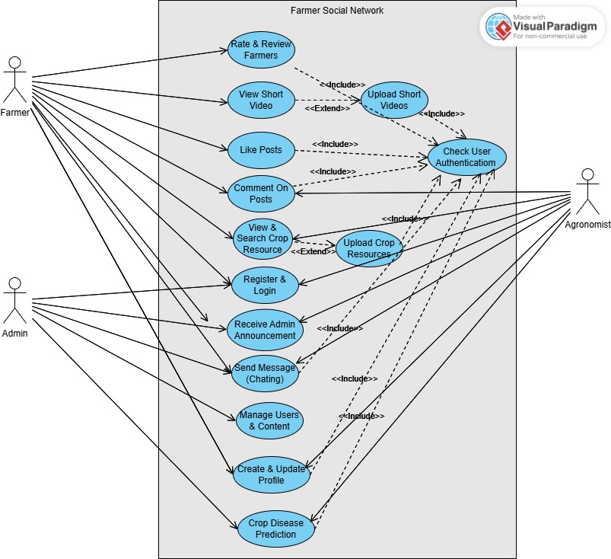

**Figure 3.5.1** Usecase Diagram

**3.5.2 Sequence Diagram**

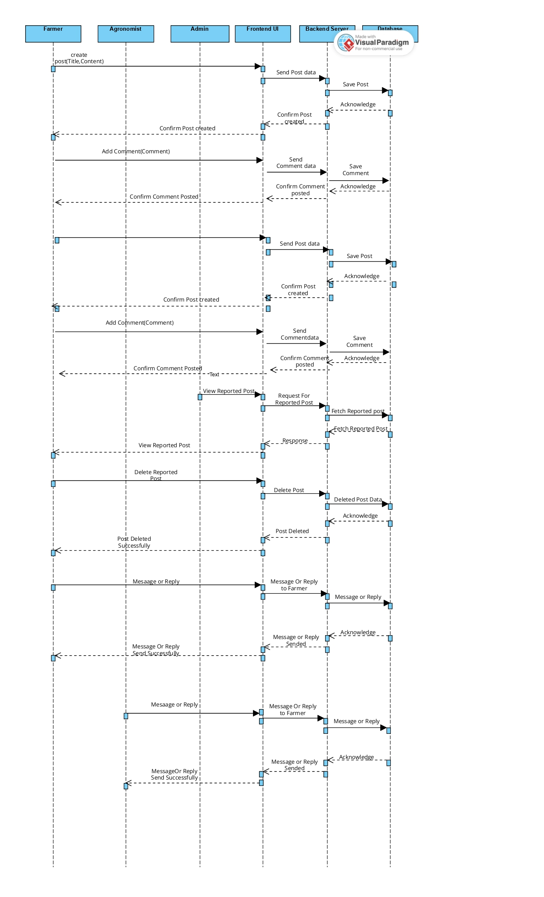

**Figure 3.5.2** Sequence Diagram

**3.5.3 Activity Diagram**

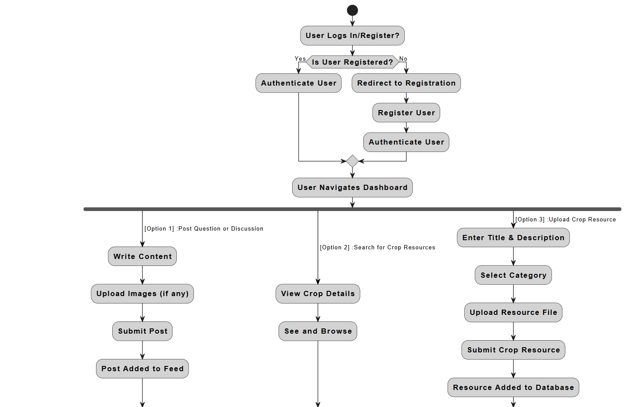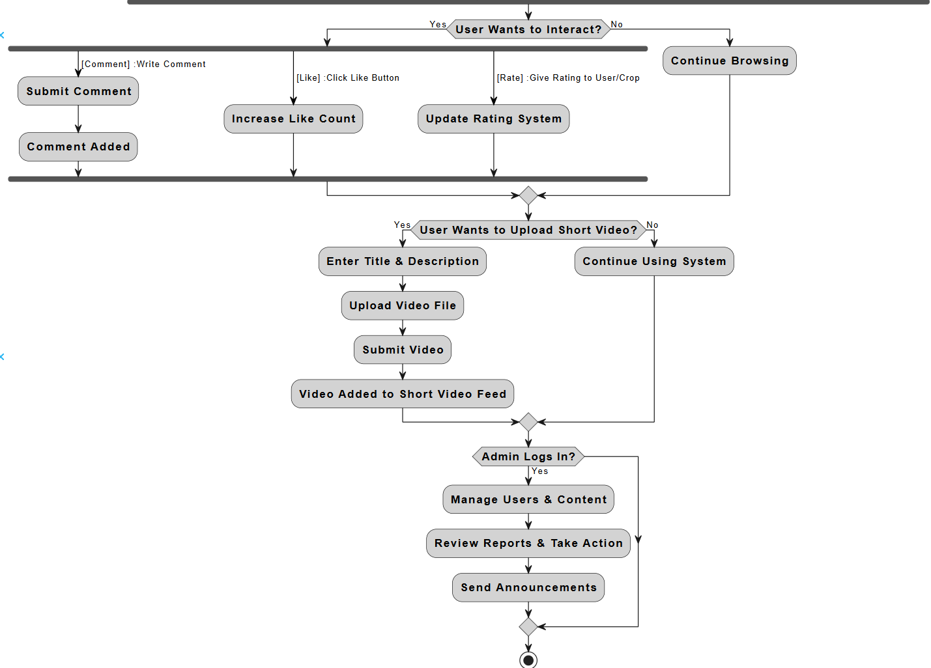

**Figure 3.5.3** Activity Diagram

**3.5.4 Class Diagram**

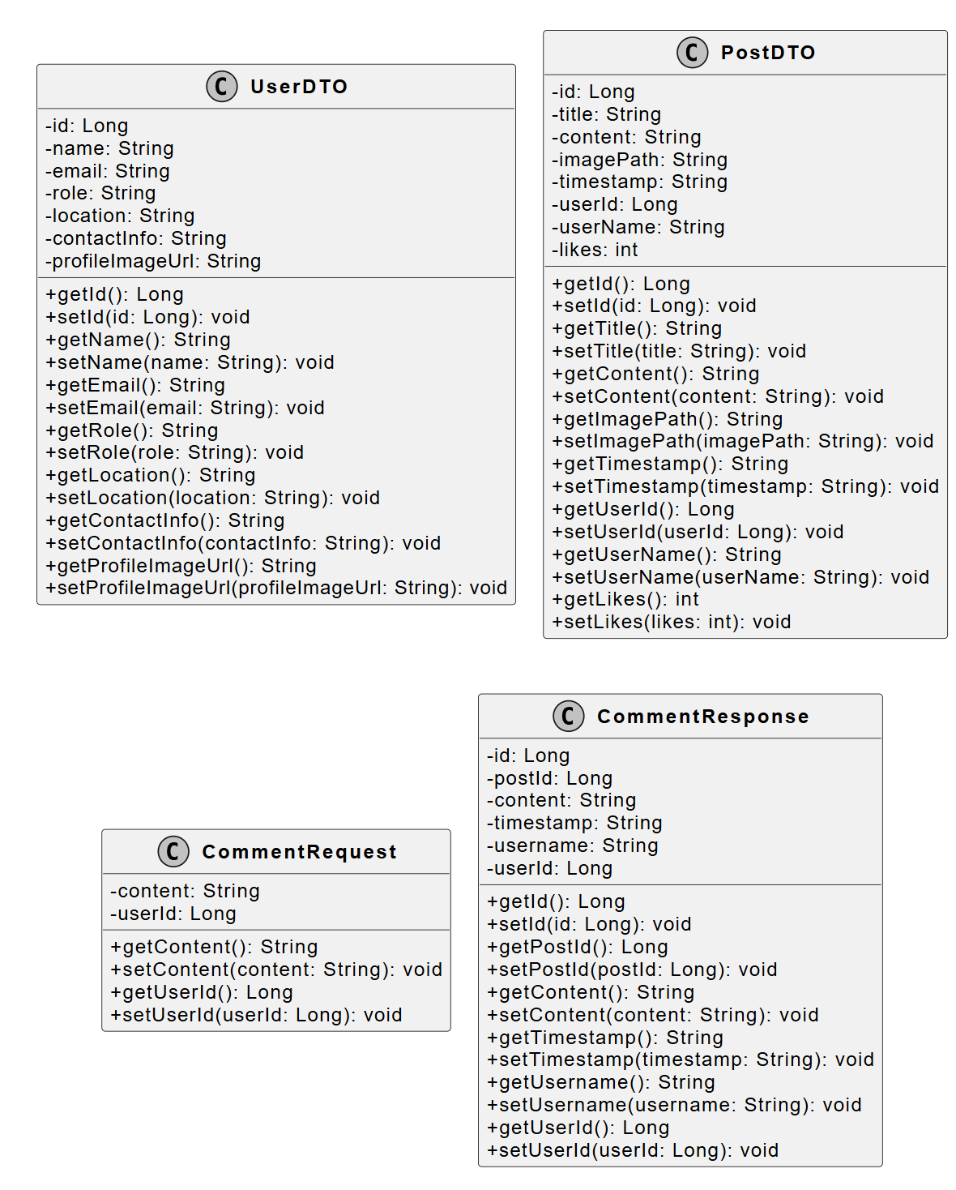

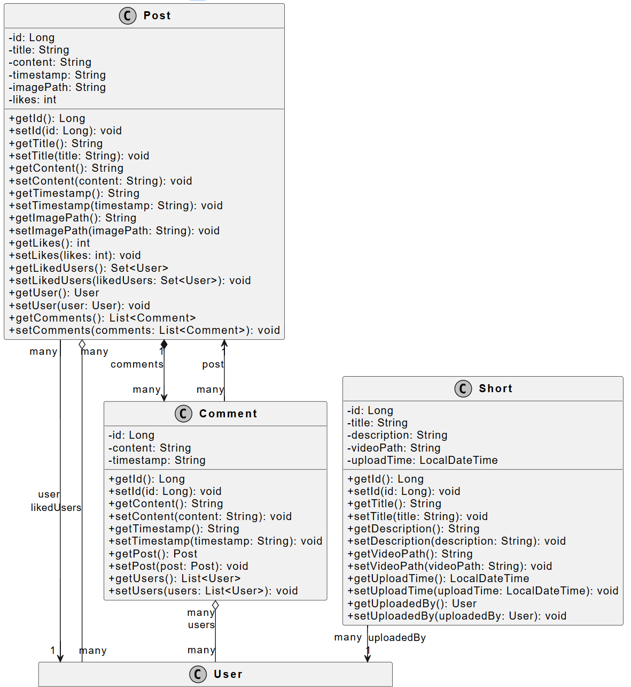

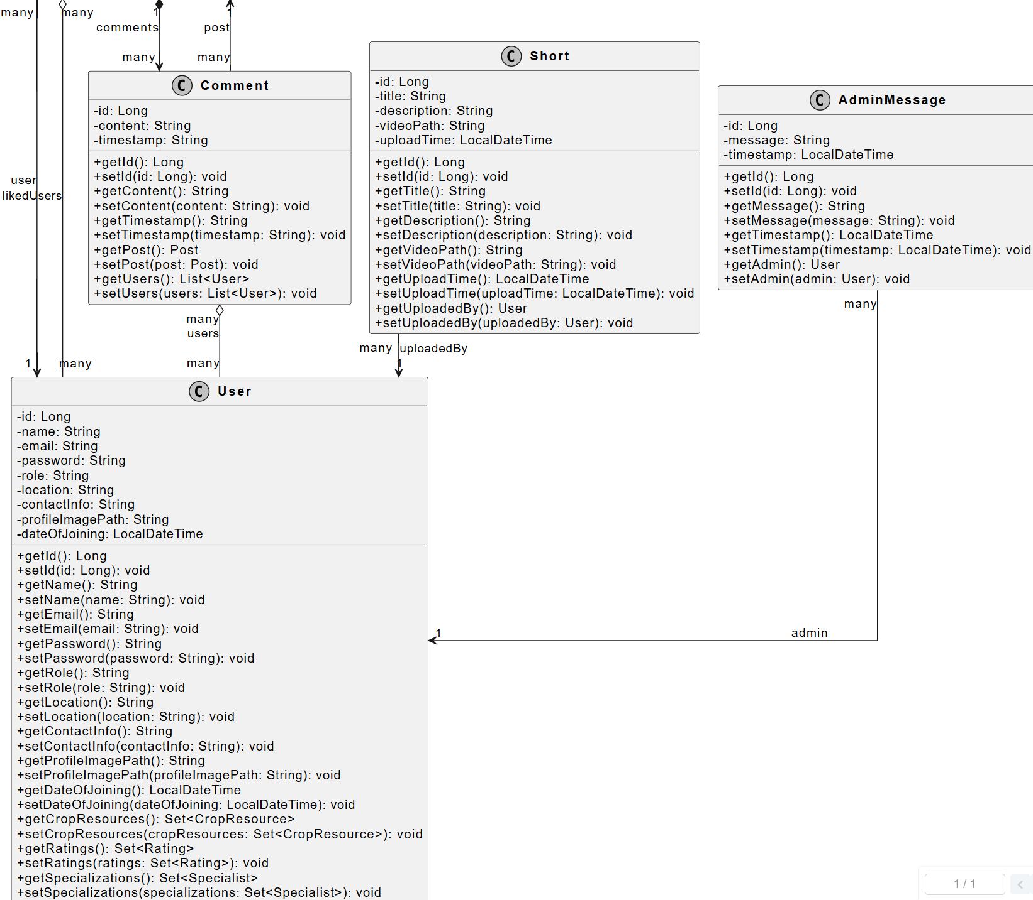

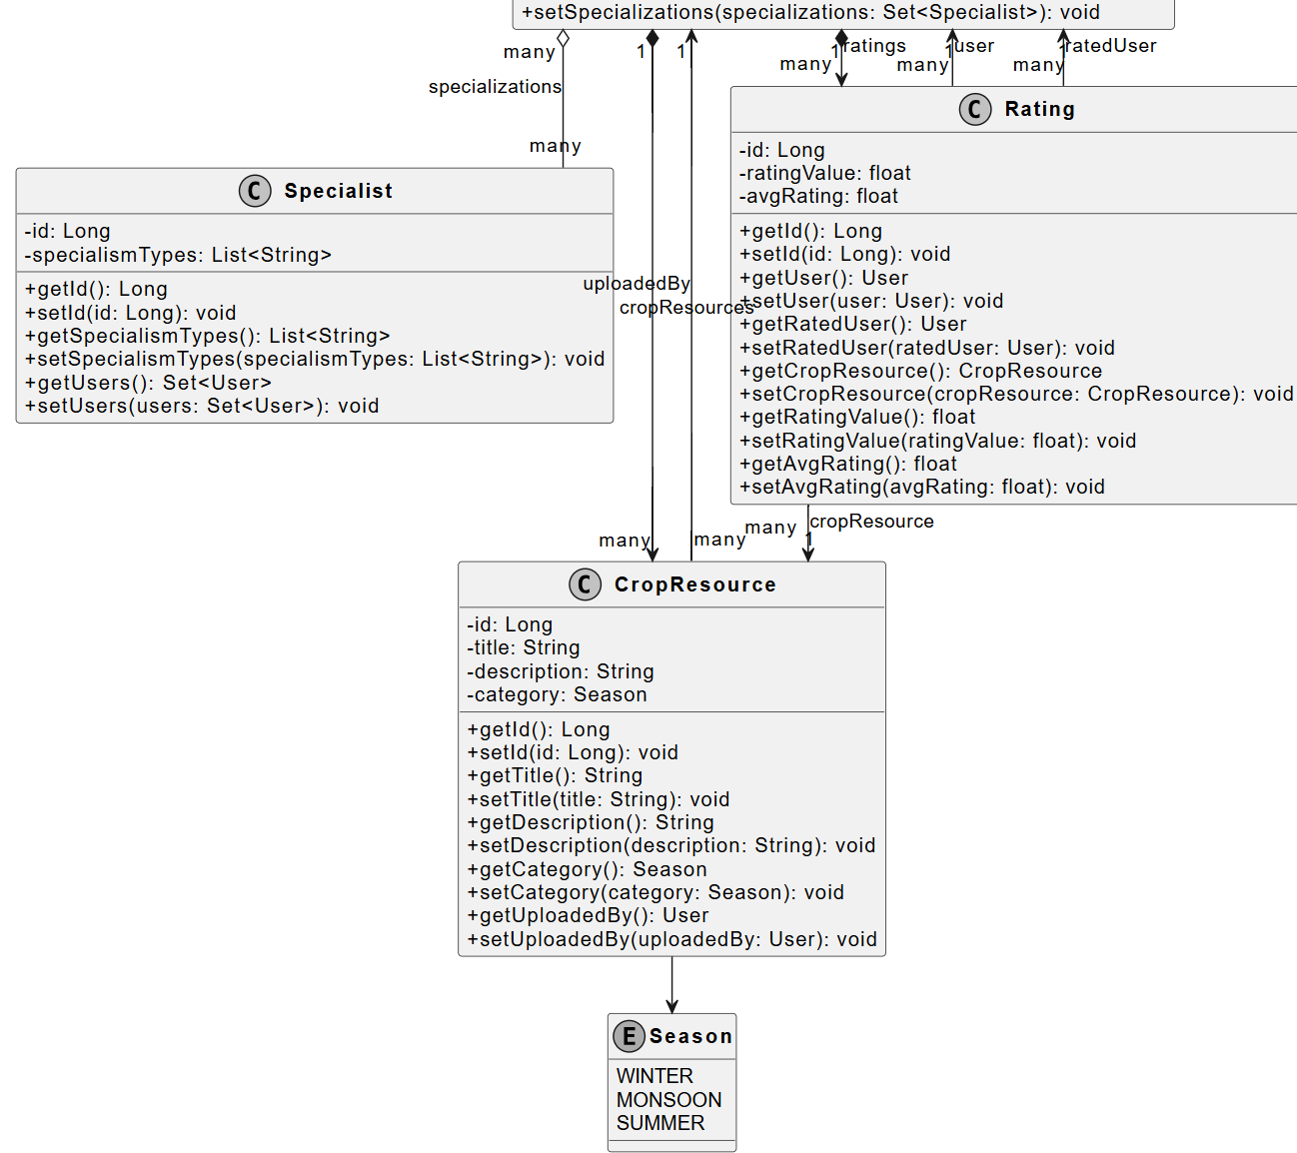

**Figure 3.5.4** Class Diagram

**3.5.5 System Architecture Diagram**

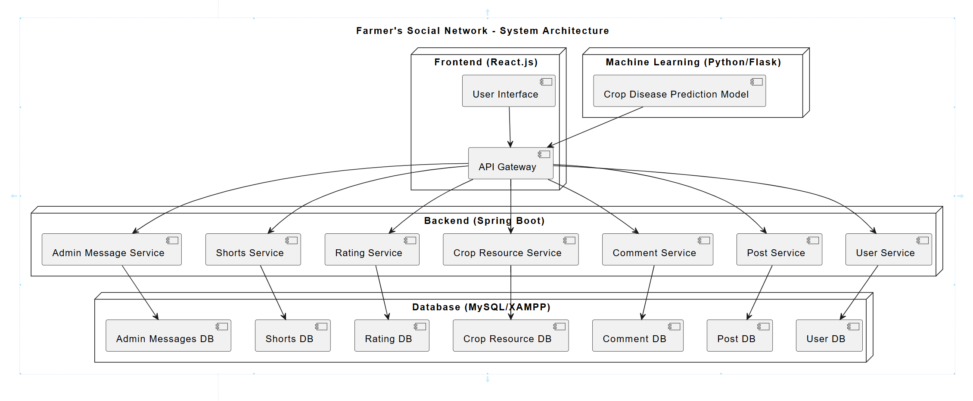

**Figure 3.5.5** System Architecture Diagram

### **Chapter 4**

### Database Design

We Use here Two Database Technology (1) **MySQL** & (2) **MongoDB** By using **both MongoDB and MySQL**, the system benefits from **high flexibility, performance, and consistency**, ensuring the best database technology is used for each specific requirement in the application.

**MySQL (Relational Database)**: Best suited for structured data where relationships between entities are crucial (e.g., transactions, user profiles,etc…).We use it here for structured data Which is Highly dependent on each other.

**MongoDB (NoSQL Database)**: Handles unstructured or semi-structured data efficiently (e.g., chat messages, logs, flexible user-generated content, etc…).We use it here for our **chat Feature**.

**4.1 MySql Schema**

**4.1.1 admin_message**

* id: bigint(20) NOT NULL
* message: varchar(255) DEFAULT NULL
* timestamp: datetime(6) DEFAULT NULL

**Sample Data:**

|  |  |  |  |
| --- | --- | --- | --- |
| **id** | **message** | **timestamp** | **admin_id** |
| 1 | System update completed. | 2025-03-24 14:06:33 | 1 |

**4.1.2 Comment**

* id: bigint(20) NOT NULL
* content: varchar(255) DEFAULT NULL
* timestamp: varchar(255) DEFAULT NULL

**Sample Data:**

|  |  |  |  |
| --- | --- | --- | --- |
| **id** | **content** | **timestamp** | **post_id** |
| 1 | nice | 2025-03-23T17:52:07.676477400 | 1 |

**4.1.3 comment_users**

* comment_id: bigint(20) NOT NULL
* user_id:bigint(20) NOT NULL

**Sample Data:**

|  |  |
| --- | --- |
| **id** | **content** |
| 1 | 1 |
| 3 | 1 |

**4.1.4 crop_resource**

* id: bigint(20) NOT NULL
* category: enum('MONSOON', ...)
* description: varchar(1000) DEFAULT NULL
* title: varchar(255) DEFAULT NULL
* uploaded_by: bigint(20) NOT NULL

**Sample Data:**

|  |  |  |  |  |
| --- | --- | --- | --- | --- |
| **id** | **category** | **description** | **title** | **Uploaded_by** |
| 3 | WINTER | ઘઉં એક મુખ્ય અનાજ પાક છે, જેનો ઉપયોગ બ્રેડ, પાસ્તા... | ઘઉં 🌾 | 7 |

**4.1.5 post**

* id: bigint(20) NOT NULL
* content: varchar(255) DEFAULT NULL
* image_path: varchar(255) DEFAULT NULL
* likes: int(11) NOT NULL
* timestamp: varchar(255) DEFAULT NULL
* title: varchar(255) DEFAULT NULL

**Sample Data:**

|  |  |  |  |  |  |  |
| --- | --- | --- | --- | --- | --- | --- |
| **id** | **content** | **image_path** | **likes** | **timestamp** | **title** | **User_id** |
| 4 | Organic farming enhances soil fertility and reduce... | http://localhost/img/1742583267362_premium_photo-1... | 3 | 1742583267362 | Best Practices for Organic Farming 🌿 | 6 |

**4.1.6 post_likes**

* post_id: bigint(20) NOT NULL
* user_id: bigint(20) NOT NULL

**Sample Data:**

|  |  |
| --- | --- |
| **post_id** | **user_id** |
| 1 | 1 |
| 2 | 3 |

**4.1.7 rating**

* id: bigint(20) NOT NULL
* avg_rating: float NOT NULL
* rating_value: float NOT NULL
* crop_resource_id: bigint(20) NOT NULL
* rated_user_id: bigint(20) NOT NULL

**Sample Data:**

|  |  |  |  |  |  |
| --- | --- | --- | --- | --- | --- |
| **id** | **avg_rating** | **rating_value** | **crop_resource_id** | **rated_user_id** | **user_id** |
| 1 | 4.5 | 4 | 2 | 2 | 1 |
| 2 | 5 | 5 | 1 | 2 | 1 |

**4.1.8 short**

* id: bigint(20) NOT NULL
* description: varchar(255) DEFAULT NULL
* title: varchar(255) DEFAULT NULL
* upload_time: datetime(6) NOT NULL
* video_path: varchar(255) NOT NULL

**Sample Data:**

|  |  |  |  |  |  |
| --- | --- | --- | --- | --- | --- |
| **id** | **description** | **title** | **upload_time** | **video_path** | **User_id** |
| 3 | રવિ સિઝનમાં ઘઉંની સારી ઉપજ મેળવવા માટે જમીન નિંદામ... | રવિ સિઝનમાં ઘઉંની ખેતી માટે મહત્ત્વપૂર્ણ સૂચનાઓ | 2025-03-24 17:09:14.000000 | /shorts_videos/1742816354861_reel1.mp4 | 8 |

**4.1.9 specialist_specialism_types**

* specialist_id: bigint(20) NOT NULL

**Sample Data:**

|  |  |
| --- | --- |
| **specialist_id** | **specialism_id** |
| 1 | Crop Management |

**4.1.10 users**

* id: bigint(20) NOT NULL
* contact_info: varchar(255) DEFAULT NULL
* date_of_joining: datetime(6) NOT NULL
* email: varchar(255) DEFAULT NULL
* location: varchar(255) DEFAULT NULL
* name: varchar(255) NOT NULL
* password: varchar(255) NOT NULL
* profile_image_path: varchar(255) DEFAULT NULL

**Sample Data:**

|  |  |  |  |  |  |  |  |  |
| --- | --- | --- | --- | --- | --- | --- | --- | --- |
| **id** | **contact_info** | **date_of_joining** | **email** | **loaction** | **name** | **password** | **profile_image_path** | **role** |
| 6 | 1111111111 | 2025-03-22 00:13:46.000000 | om@gmail.com | Godhra | Om Patel | om | asdf.png | farmer |
| 7 | 2222222222 | 2025-03-22 00:14:36.000000 | vanraj@gmail.com | Khambhat | Vanraj Parmar | vanraj | images.jpg | agronomis |
| 8 | 3333333333 | 2025-03-22 00:15:10.000000 | sahil@gmail.com | Junagadh | Sahil Sorathiya | sahil | sustainability.jpg | admin |

**4.1.11 user_specialist**

* user_id: bigint(20) NOT NULL
* specialist_id: bigint(20) NOT NULL
* **Sample Data:**

|  |  |
| --- | --- |
| **user_id** | **specialist_id** |
| 2 | 1 |

**4.2 MongoDb Schema**

**4.2.1 Users Collection**

**{**

"users": {

"uid": "String",

"username": "String",

"password": "String",

"email": "String",

"phoneNo": "String",

"profilePicture": "String",

"language": "String",

"bio": "String",

"contact": [

{

"receiver": "ObjectId",

"lastSeen": "Date"

}

],

"group": ["ObjectId"],

"isOnline": "Boolean",

"createdAt": "Date",

"updatedAt": "Date"

}**}**

**Sample Data:**

{

"_id": "ObjectId('67df9725069fc2c384f8d07e')",

"username": "om patel",

"password":"1234",

"email": "vv@gmail.com",

"phoneNo": "9856325897",

"profilePicture": null,

"language": "English",

"bio": "✓",

"group": [],

"isOnline": false,

"createdAt": "2025-03-23T05:07:49.619+00:00",

"updatedAt": "2025-03-23T05:07:49.619+00:00",

"contact": [

{

"receiver": "67df96a0069fc2c384f8d07b",

"lastSeen": "2025-03-24T05:08:33.371+00:00",

"_id": "67e0e8a8d935c4d99c2ed49c"

}

],

"__v": 3

}

**4.2.2 Message Collection**

**{**

"messages": {

"msg_id": "String",

"content": "String",

"timestamp": "Date",

"sender": "ObjectId",

"group": "ObjectId",

"receiver": "ObjectId",

"starred": "Boolean",

"type": "String",

"isDirectMsg": "Boolean",

"isRead": "Boolean",

"translatedContent": "String"

}

**}**

**Sample Data:**

{

"_id": "ObjectId('67e166e9fb043c9649dcd9c4')",

"content": "Work Is Done...",

"timestamp": "2025-03-24T14:06:33.052+00:00",

"sender": "ObjectId('67df96a0069fc2c384f8d07b')",

"receiver": "ObjectId('67df9725069fc2c384f8d07e')",

"starred": false,

"type": "msg",

"isRead": false,

"translatedContent": null,

"__v": 0

}

### **Chapter 5**

### Implementation Details

**5.1 Frontend Implementation**

* Developed using **React.js** with **Material UI** for a responsive UI.
* **State Management:** Uses React's built-in state (useState, useContext) for managing UI and data flow.
* **Routing:** Implemented with **React Router** for seamless navigation.
* **API Integration:** Uses **Axios** to interact with the backend.
* **Real-Time Features:** Supports **instant messaging** using **Socket.IO**.
* **File Uploads:** Enables users to **upload images and videos** for posts and crop disease predictions.

**5.2 Backend Implementation**

* Built with **Spring Boot**, following a **REST API architecture**.
* **Authentication:** Uses **session-based authentication** for user login.
* **Database:**
  + **MySQL (XAMPP)** for relational data storage.
  + **MongoDB Atlas** for chat-related data.
* **Machine Learning:** Use Deep learning based CNN model for **crop disease prediction**.
* **Real-Time Messaging:** Uses **Socket.IO** for live chat between users.
* **Content Management:** Implements CRUD operations for **posts, comments, crop-resources etc.**
* **Moderation:** Admins can **manage content** for quality control.

**5.3 ML Implementation**

**Why Machine Learning (ML) is Used?**

Traditional programming cannot effectively classify crop diseases from images due to variations in lighting, angle, and background. Machine Learning, specifically Deep Learning using **Convolutional Neural Networks (CNNs)**, can automatically extract meaningful patterns and features from images. This allows the model to accurately predict crop diseases without requiring handcrafted rules.

**How Machine Learning is Used?**

**1. Data Preparation & Augmentation**

* **Dataset Handling**: Images are loaded from directories for training and validation.
* **Augmentation (ImageDataGenerator)**: Enhances model robustness using rescaling, rotation, shifting, zooming, and flipping to prevent overfitting.
* **Categorical Classification**: Since multiple diseases exist, class_mode='categorical' is used.

**2. CNN Model Architecture**

* **Convolutional Layers (Conv2D)**: Extracts essential features like edges and textures.
* **Batch Normalization**: Stabilizes training by normalizing activations.
* **Max Pooling (MaxPooling2D)**: Reduces feature map dimensions while preserving crucial details.
* **Global Average Pooling (GlobalAveragePooling2D)**: Converts feature maps into a vector.
* **Dropout (Dropout)**: Prevents overfitting by randomly deactivating neurons.
* **Fully Connected Layers (Dense)**:
  + **ReLU Activation**: Adds non-linearity for better learning.
  + **Softmax Activation**: Outputs probabilities for multi-class classification.

**3. Model Compilation & Training**

* **Optimizer: 'adam'** – Adaptive learning rate for efficient convergence.
* **Loss Function: 'categorical_crossentropy'** – Suitable for multi-class classification.
* **Evaluation Metric: 'accuracy'** – Measures correct predictions.
* **ReduceLROnPlateau**: Lowers learning rate when validation loss stagnates, improving training stability.
* **Epochs & Batch Size**: Trained for **20 epochs** with **batch size 32**.

**4. Model Saving & Visualization**

* The trained model is saved (.h5 format) in Google Drive for deployment.
* **Performance Graphs** (Accuracy & Loss) are plotted to analyze training progress.

### **Chapter 6**

### Testing

**6.1. Testing Framework and Methodology:**

* **Unit Testing**: Frontend forms, navigation, and responsiveness across multiple browsers.
* **Endpoint Testing**: Postman for API endpoints.

**6.2. Test Cases:**

|  |  |  |  |  |  |  |
| --- | --- | --- | --- | --- | --- | --- |
| **Test**  **Case**  **ID** | **Description** | **Test Steps** | **Input** | **Expected**  **Output** | **Actual**  **Output** | **Status** |
| TC_01 | User Registration | 1. Open registration page. 2. Enter valid details. 3. Click "Sign Up". | Name, Email, Password,  Location,  Role,Phone No.,Profile Image | "Registration successful!" | "Registration successful!" | Pass |
| TC_02 | Invalid Registration | 1. Open registration page. 2. Enter invalid/missing details. 3. Click "Sign Up". | Missing or invalid fields | "Registration failed. Please try again." | "Registration failed. Please try again." | Pass |
| TC_03 | User Login | 1. Open login page. 2. Enter correct email, password, and role. 3. Click "Login". | Valid Email, Password, Role | "Welcome back, User!" | "Welcome back, User!" | Pass |
| TC_04 | Invalid Login | 1. Open login page. 2. Enter incorrect credentials. 3. Click "Login". | Wrong Email, Password, or Role | "Login Failed. Invalid credentials or role. Please try again." | "Login Failed. Invalid credentials or role. Please try again." | Pass |
| TC_05 | Create Post | 1. Login as user. 2. Open "Create Post". 3. Enter title, content, upload image. 4. Click "Post". | Title, Content, Image | "🎉 Post Uploaded! Your post has been uploaded successfully!" | "🎉 Post Uploaded! Your post has been uploaded successfully!" | Pass |
| TC_06 | Create Post with Missing Fields | 1. Login as user. 2. Open "Create Post". 3. Click "Post" without entering all details. | Missing fields | "All fields are required. Please fill out the form completely." | "All fields are required. Please fill out the form completely." | Pass |
| TC_07 | Post Upload Without Login | 1. Try creating a post without logging in. | No login session | "User is not logged in or user ID is unavailable." | "User is not logged in or user ID is unavailable." | Pass |
| TC_08 | Post Upload Failure | 1. Login as user. 2. Fill in all details. 3. Click "Post". (Simulate failure) | Title, Content, Image | "Failed to upload the post. Please try again later." | "Failed to upload the post. Please try again later." | Pass |
| TC_09 | Comment on Post | 1. Login as user. 2. Open a post. 3. Enter a comment. 4. Click "Submit". | Comment Text | Comment added successfully | Comment added successfully | Pass |
| TC_10 | Like a Post | 1. Login as user. 2. Open a post. 3. Click "Like". | Click on "Like" | Like count increases by 1 | Like count increases by 1 | Pass |
| TC_11 | Delete A Post | 1.Login as user  2.Open your Post Section  3.Delete The Post | Click On Delete Icon | Post Deleted Successfully | Post Deleted Successfully | Pass |
| TC_12 | Upload Crop Resource | 1. Login as agronomist. 2. Open "Crop Resource". 3. Fill title, description, category. 4. Click "Upload". | Title, Description, Category | "🎉 Upload Successful! Resource uploaded successfully!" | "🎉 Upload Successful! Resource uploaded successfully!" | Pass |
| TC_13 | Upload Crop Resource Without Category | 1. Login as agronomist. 2. Fill in title and description but no category. 3. Click "Upload". | No category | "⚠️ Missing Category. Please select a category." | "⚠️ Missing Category. Please select a category." | Pass |
| TC_14 | Unauthorized Crop Resource Upload | 1. Login as farmer. 2. Try uploading a crop resource. | Farmer role | "⚠️ Access Denied. Only agronomists can upload resources." | "⚠️ Access Denied. Only agronomists can upload resources." | Pass |
| TC_15 | Crop Resource Upload Failure | 1. Login as agronomist. 2. Fill details. 3. Click "Upload". (Simulate failure) | Title, Description, Category | "❌ Upload Failed. Error uploading resource. Please try again." | "❌ Upload Failed. Error uploading resource. Please try again." | Pass |
| TC_16 | View Crop List & Submit Rating | 1. Login as user. 2. Navigate to "Crop List". 3. Select a crop. 4. Submit rating. | Select crop, rate | "Rating submitted successfully!" | "Rating submitted successfully!" | Pass |
| TC_17 | AI Crop Diagnosis - Upload Image | 1. Login as user. 2. Open "AI Crop Diagnosis". 3. Upload image. 4. Click "Predict". | Crop Image | Disease prediction displayed | Disease prediction displayed | Pass |
| TC_18 | AI Crop Diagnosis - No Image | 1. Login as user. 2. Open "AI Crop Diagnosis". 3. Click "Predict" without uploading an image. | No Image | "Please upload an image first." | "Please upload an image first." | Pass |
| TC_19 | Upload Short Video (Reel) | 1. Login as user. 2. Open "Reels". 3. Fill title, description, upload video. 4. Click "Upload". | Title, Description, Video File | "Short uploaded successfully. Your short has been uploaded!" | "Short uploaded successfully. Your short has been uploaded!" | Pass |
| TC_20 | Upload Short Video - No File | 1. Login as user. 2. Open "Reels". 3. Click "Upload" without selecting a file. | No video file | "Upload Failed. Error uploading short, please try again." | "Upload Failed. Error uploading short, please try again." | Pass |
| TC_21 | Uploading Short Video - In Progress | 1. Upload a short video. 2. Observe status during upload. | Title, Description, Video File | "Uploading... Please wait while we upload your short." | "Uploading... Please wait while we upload your short." | Pass |
| TC_22 | Chat Application - Send Message | 1. Login as user. 2. Open chat. 3. Select a contact. 4. Send message. | Message text | Message delivered successfully | Message delivered successfully | Pass |
| TC_23 | Chat Application - Receive Message | 1. Login as user. 2. Open chat. 3. Wait for a message from another user. | Incoming message | Message received in real-time | Message received in real-time | Pass |
| TC_24 | Get the Guidance From Application | 1.Login as farmer  2.Go Farmer DashBoard | Click On Farmer Dashboard | Information About The Crops | Information About The Crops | Pass |
| **TC_25** | **Profile Update** | 1. Login as user. 2. Open "Profile". 3. Edit details. 4. Click "Save". | Updated profile details | **"Profile updated successfully!"** | **"Profile updated successfully!"** | Pass |
| **TC_26** | **Profile Update - No Changes** | 1. Open profile page. 2. Click "Save" without making changes. | No changes | **"No changes made to the profile."** | **"No changes made to the profile."** | Pass |
| **TC_27** | **Admin Sends Message** | 1. Login as admin. 2. Open "Send Message". 3. Select recipient. 4. Enter message. 5. Click "Send". | Message Text | **"Message sent successfully!"** | **"Message sent successfully!"** | Pass |
| TC_28 | Update Specialization (Agronomist Only) | 1. Login as an **Agronomist**.  2. Open "Specialization Settings".  3. Select/modify specializations.  4. Click "Save". | List of specializations selected | "Success! Specializations updated successfully." | "Success! Specializations updated successfully." | Pass |

### **Chapter 7**

### Screen Short

**7. ScreenShots of UI**

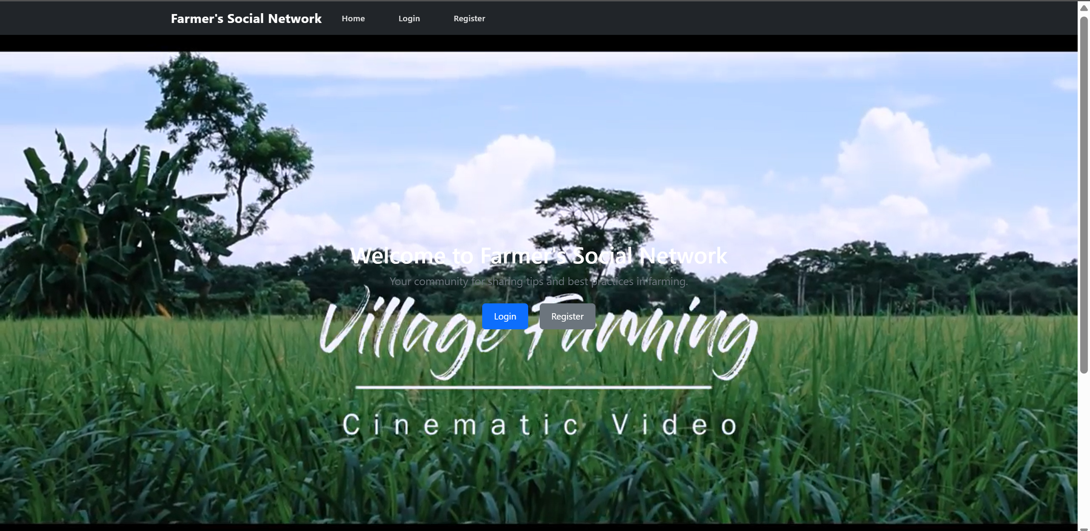

**Figure 7.1** Dashboard

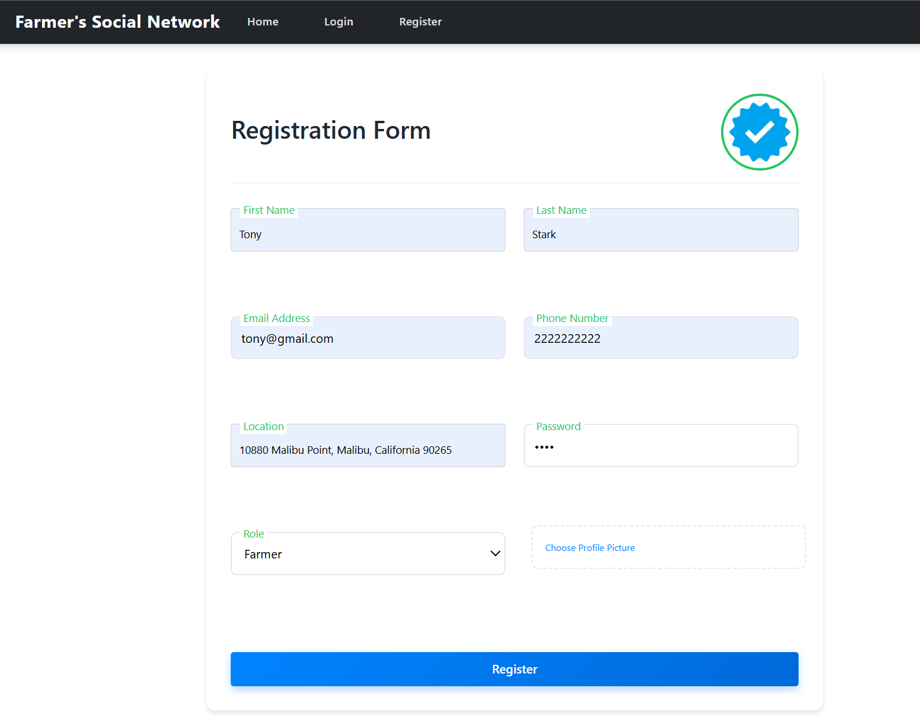

**Figure 7.2** Registration Page



**Figure 7.3** Message For Successful Registration

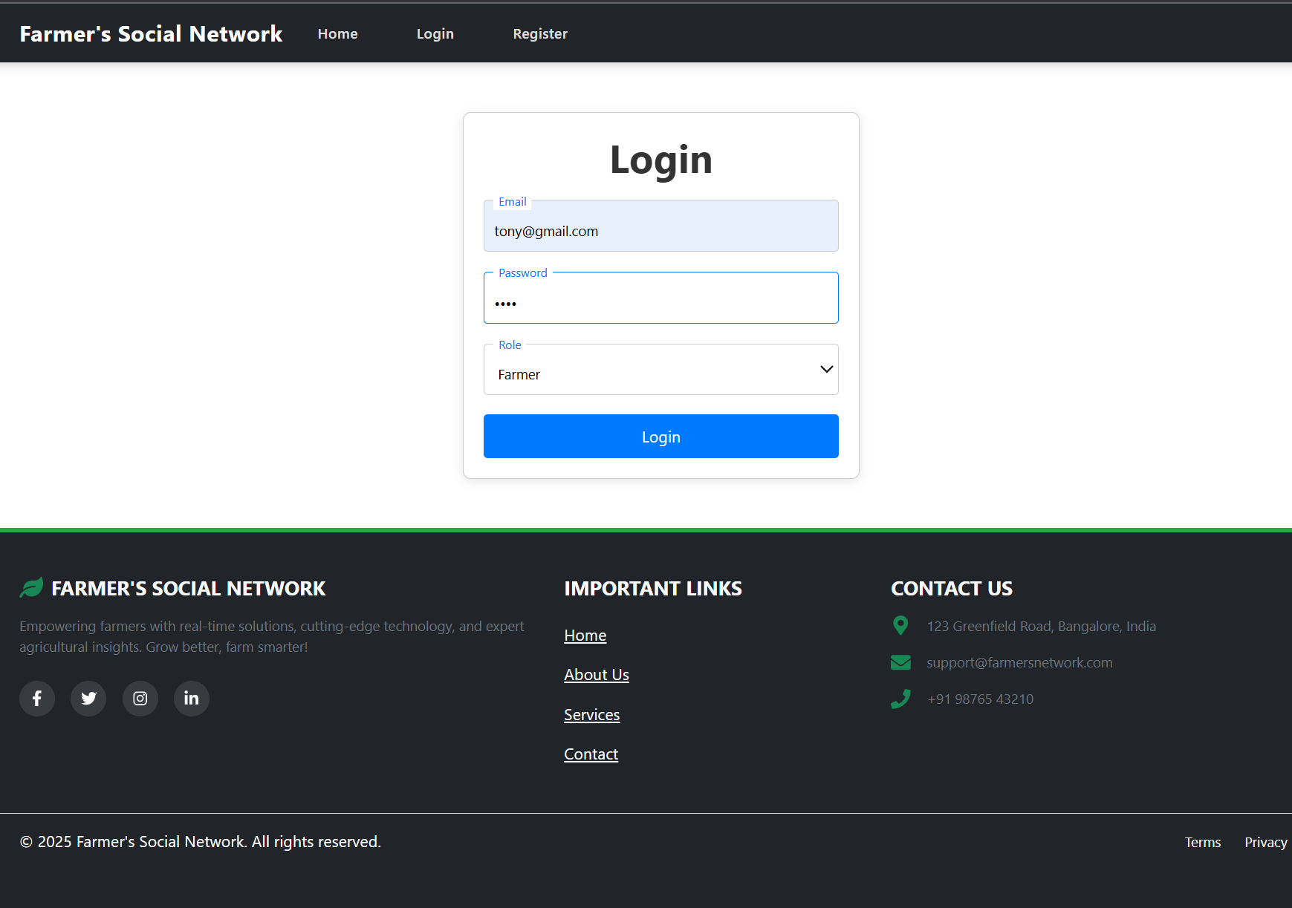

**Figure 7.4** Login page

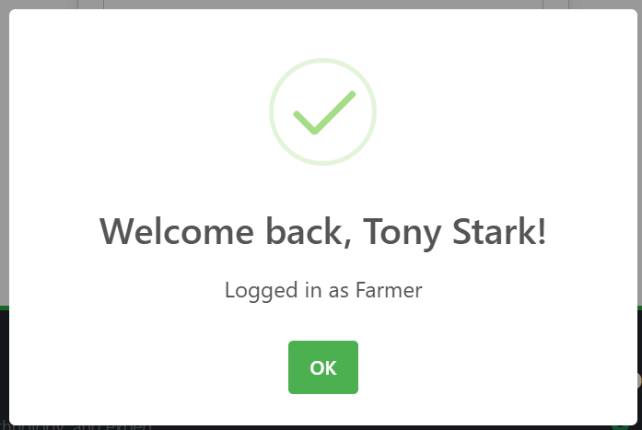

**Figure 7.5** Message For Successful Login

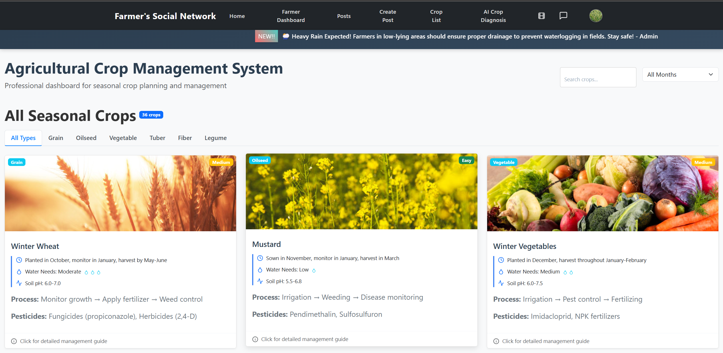

**Figure 7.6** Farmer Dashboard

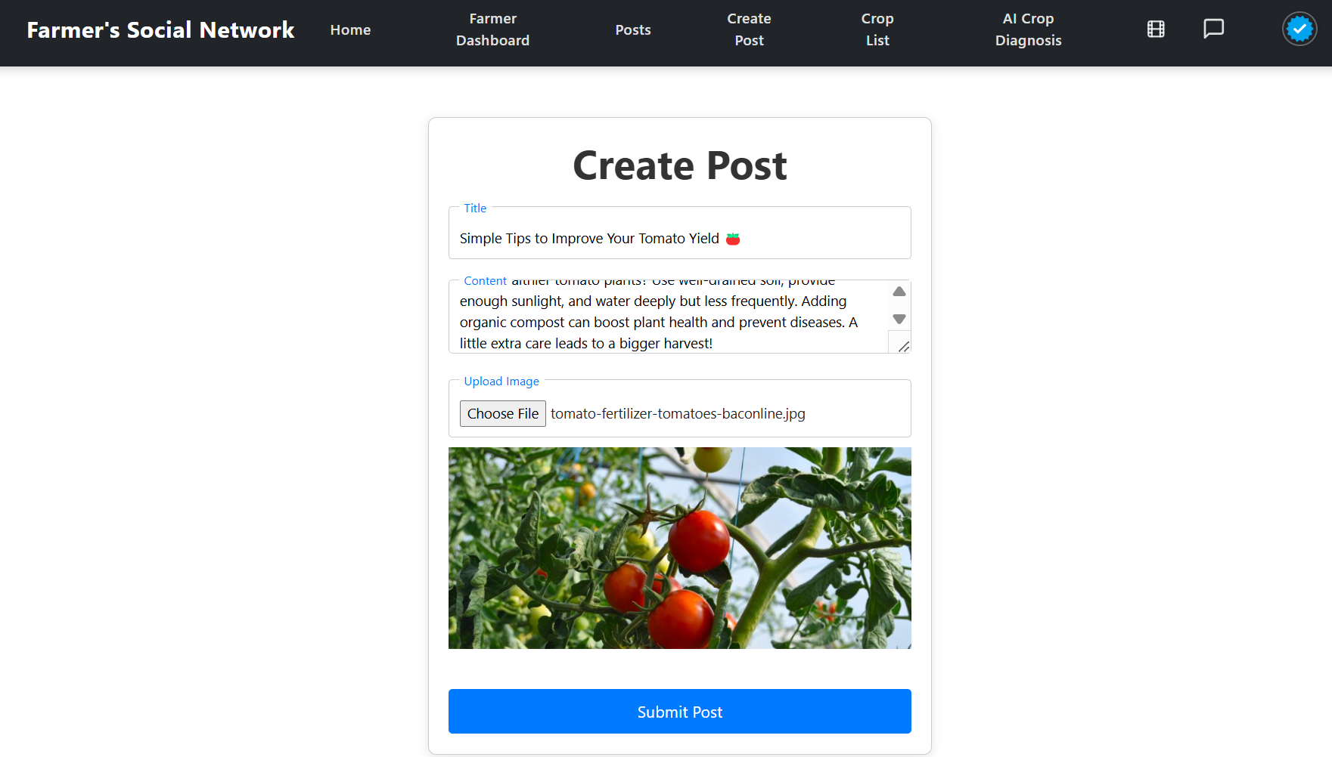

**Figure 7.7** Cretate post Page



**Figure 7.8** Message For Successful Post Creation

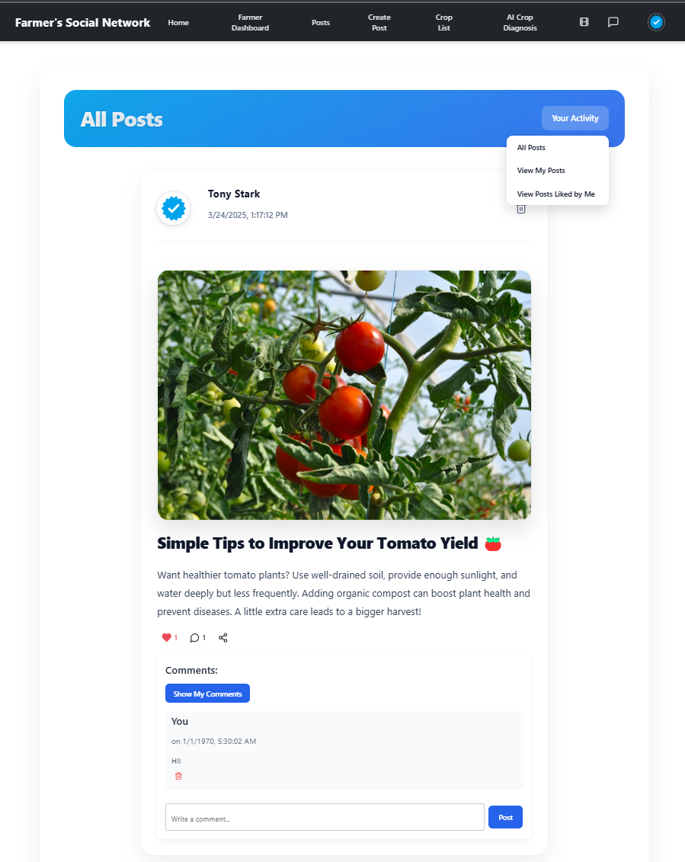

**Figure 7.9** Post Section

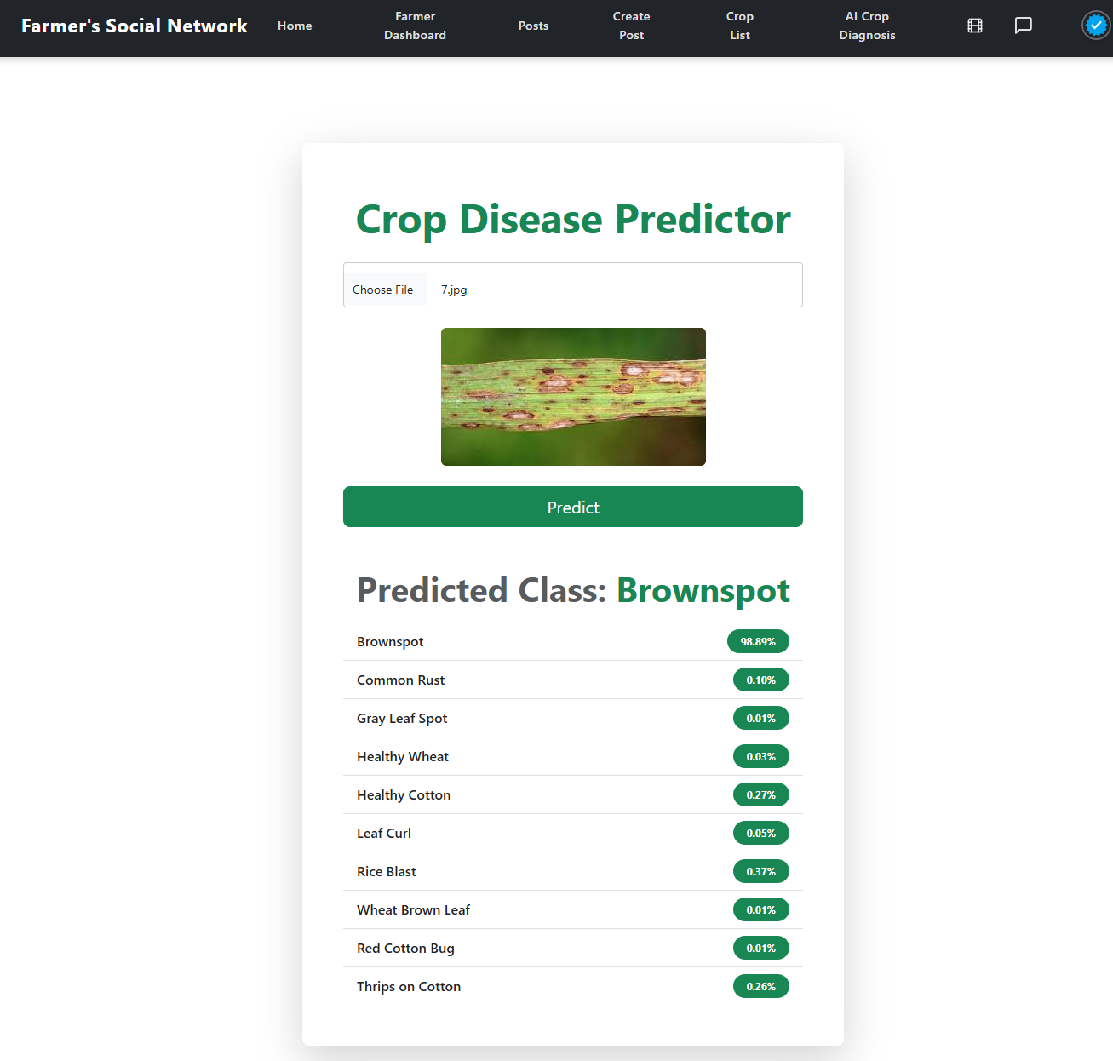

**Figure 7.10** Crop Disease Pediction

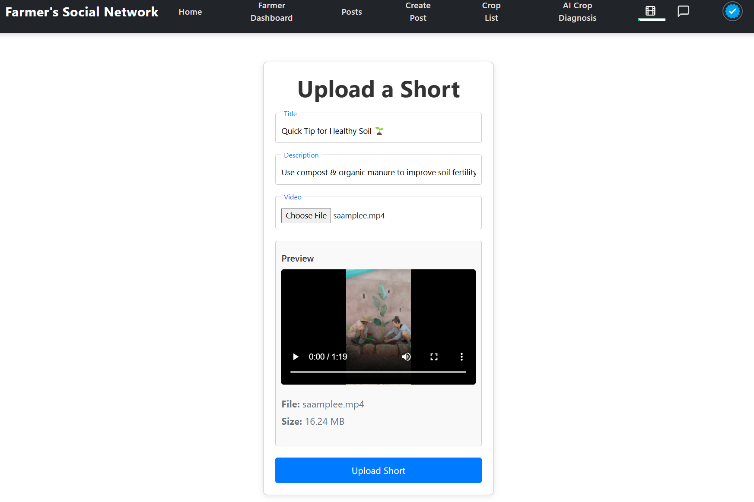

**Figure 7.11** Upload short

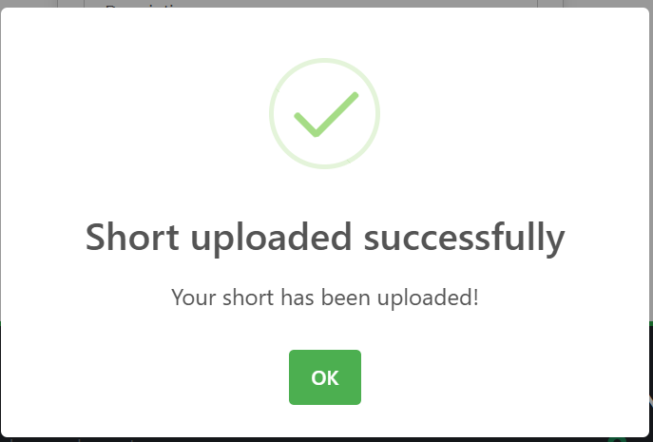

**Figure 7.12** Message For Successful Upload Short

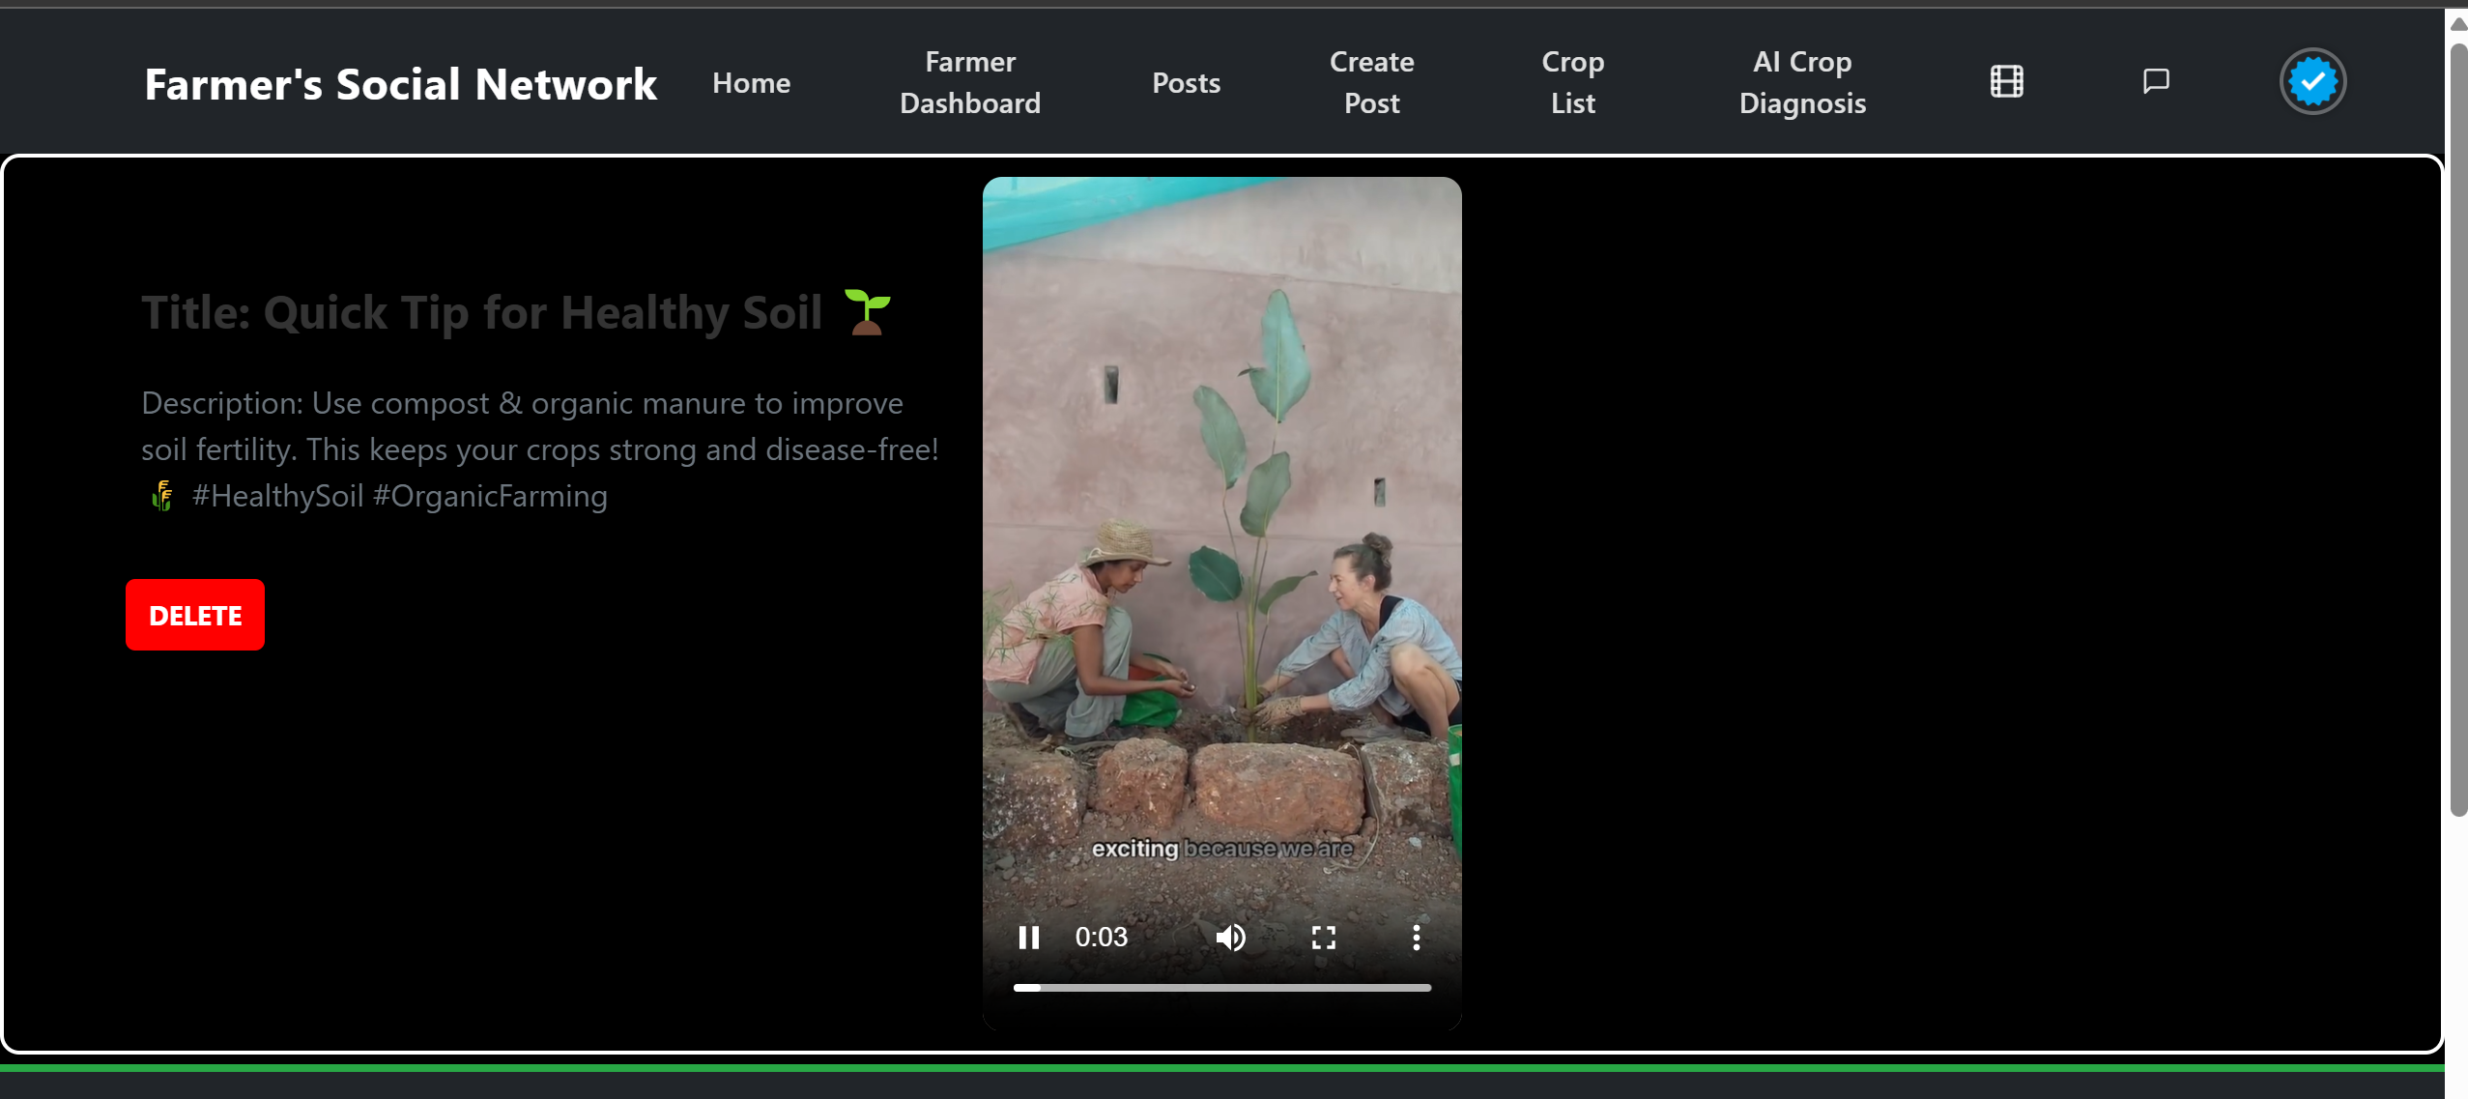

**Figure 7.13** Shorts Feed

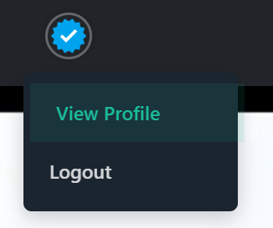

**Figure 7.14** Profile View

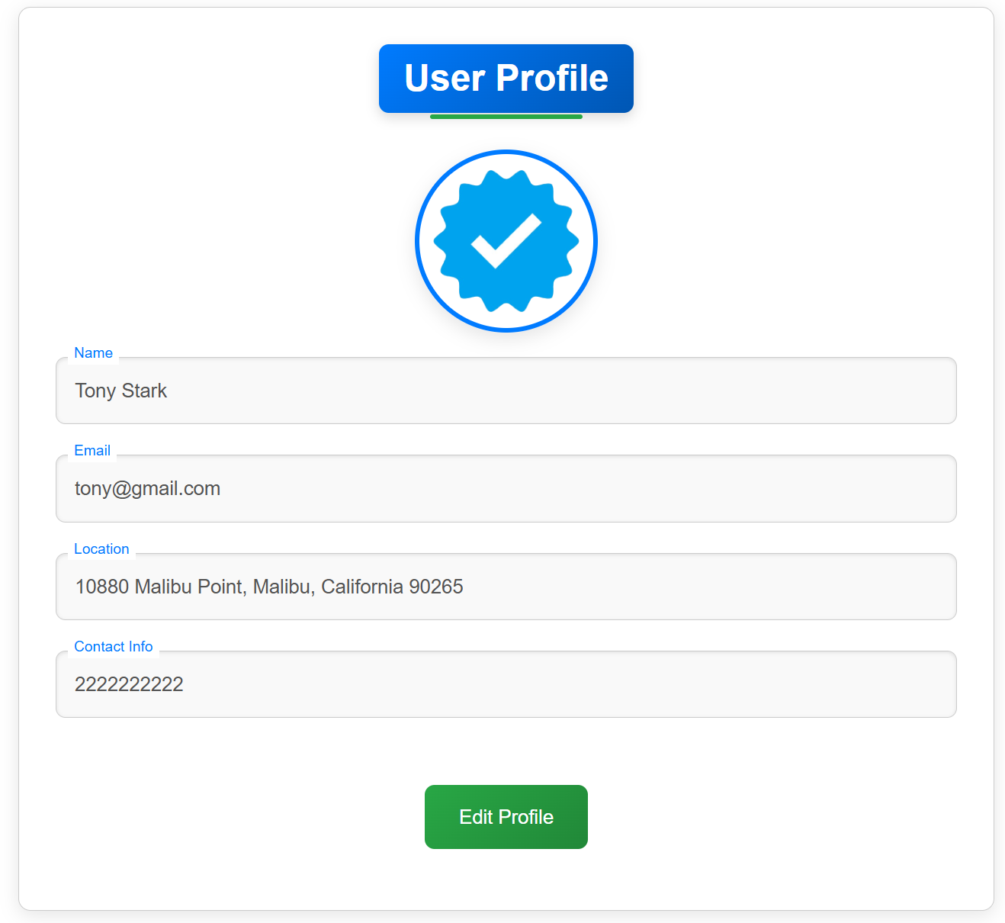

**Figure 7.15** Profile Page

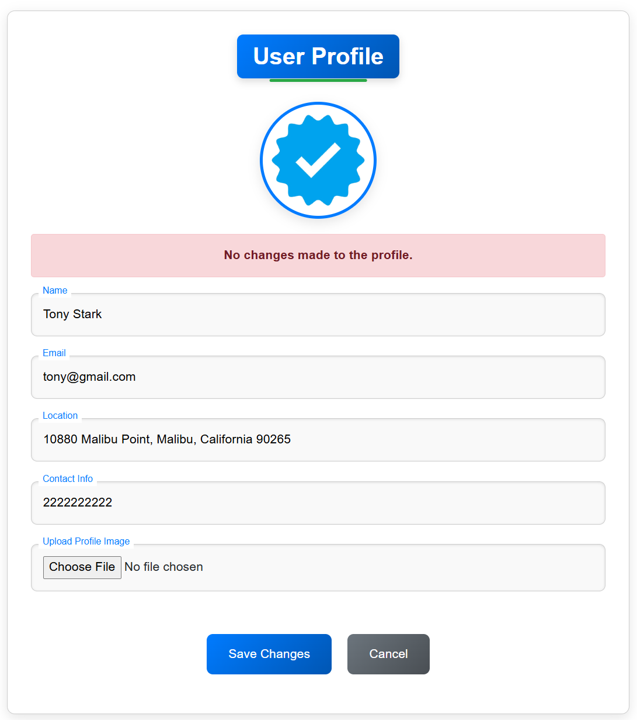

**Figure 7.16** Profile Updation

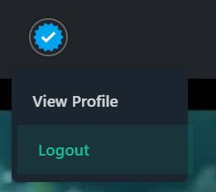

**Figure 7.17** Logout

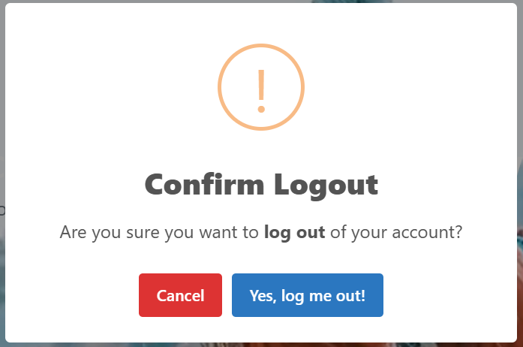

**Figure 7.18** Message For Confirm Logout

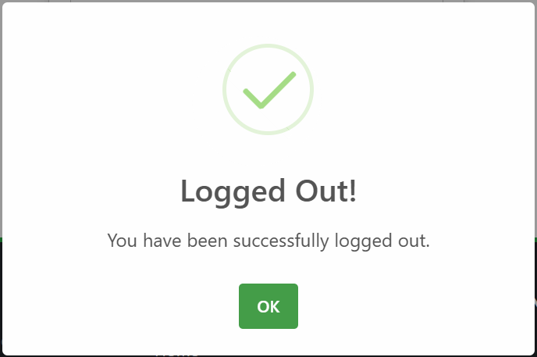

**Figure 7.19** Message For Successful Logout

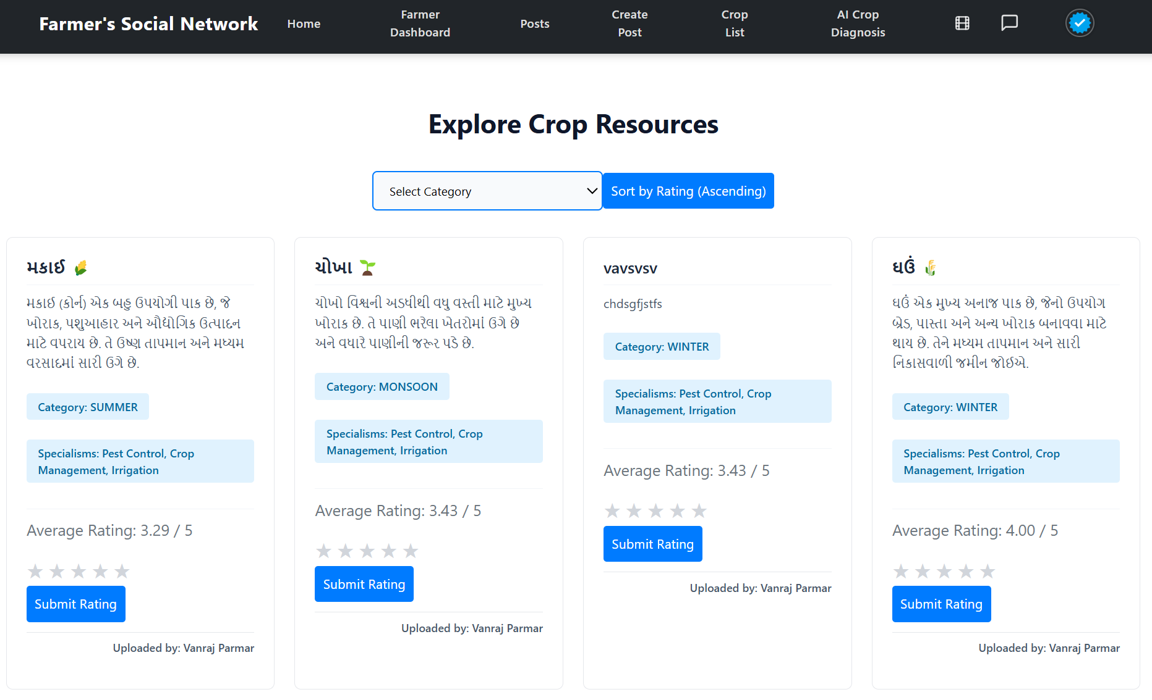

**Figure 7.20** Explore Crop Resources

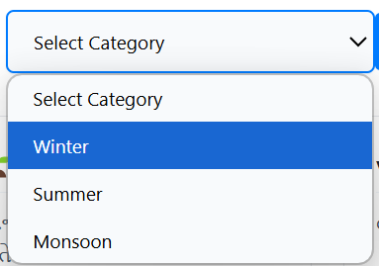

**Figure 7.21** Selection Of Category

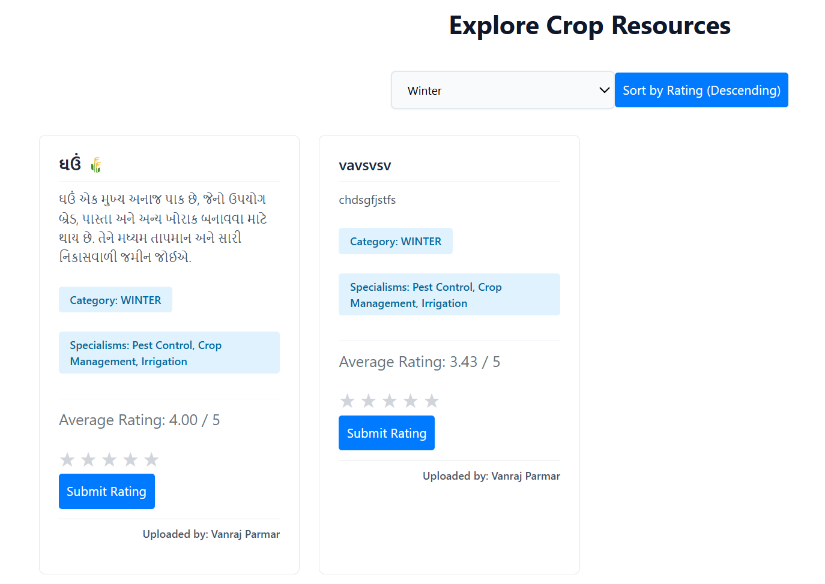

**Figure 7.22** Result Of Selection Of Crop Resource

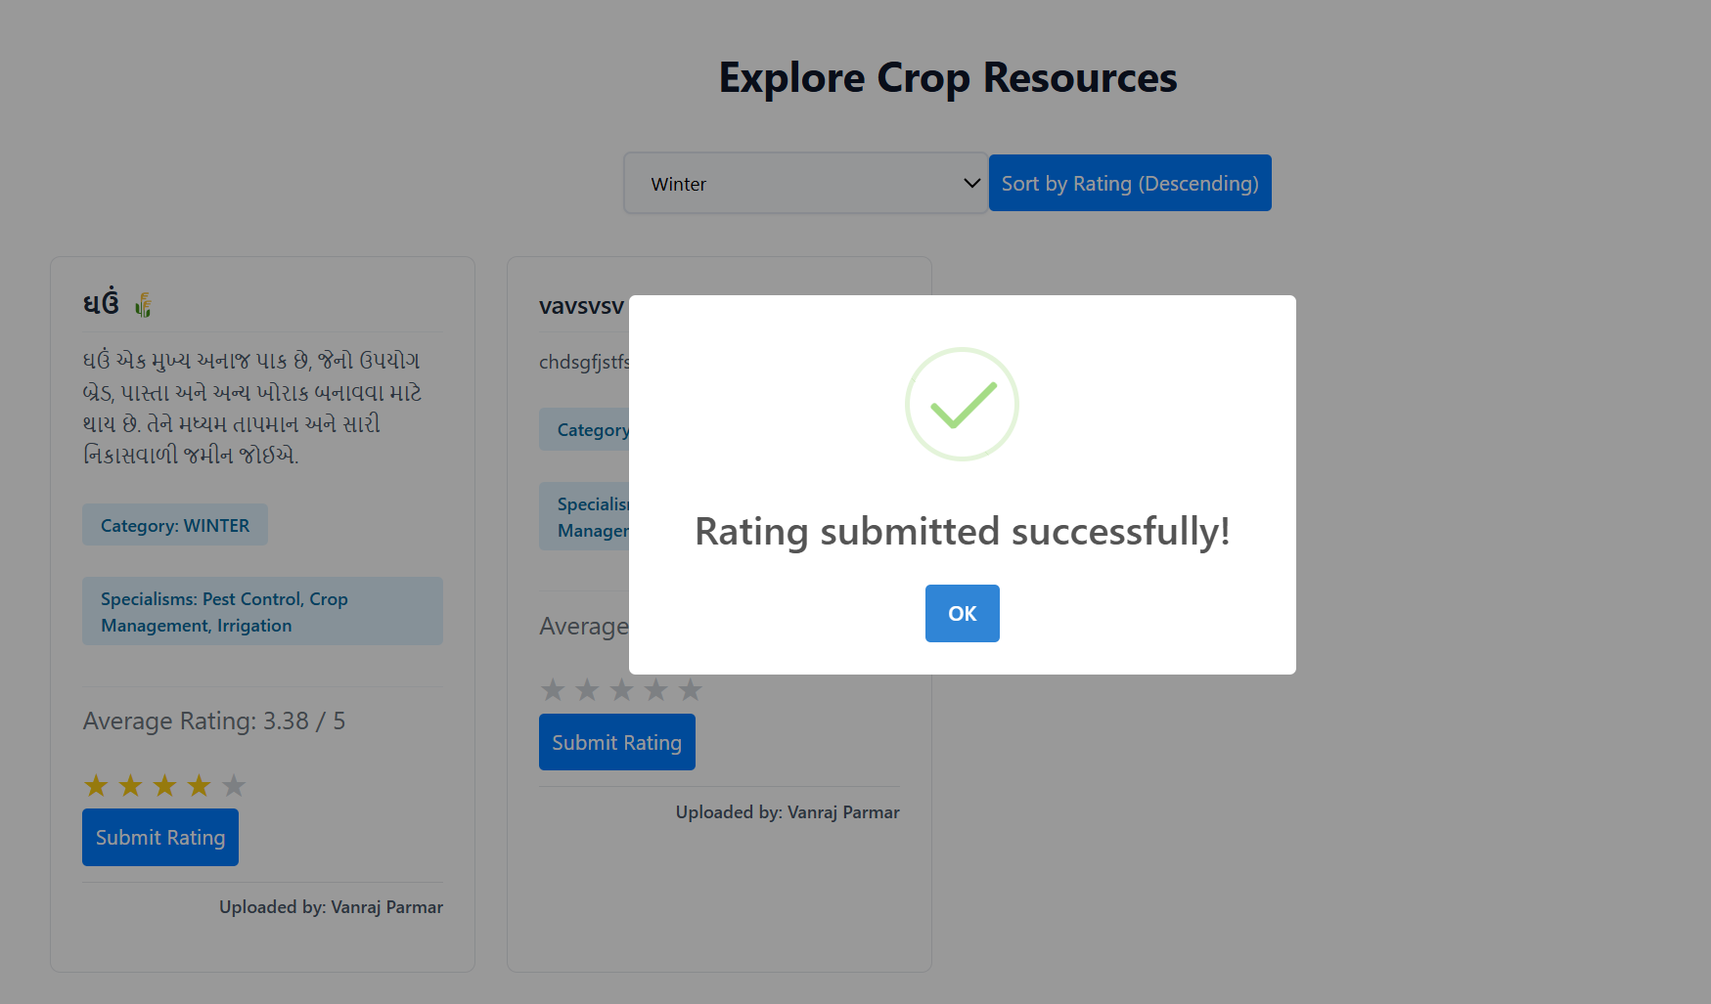

**Figure 7.23** Rating The Resource

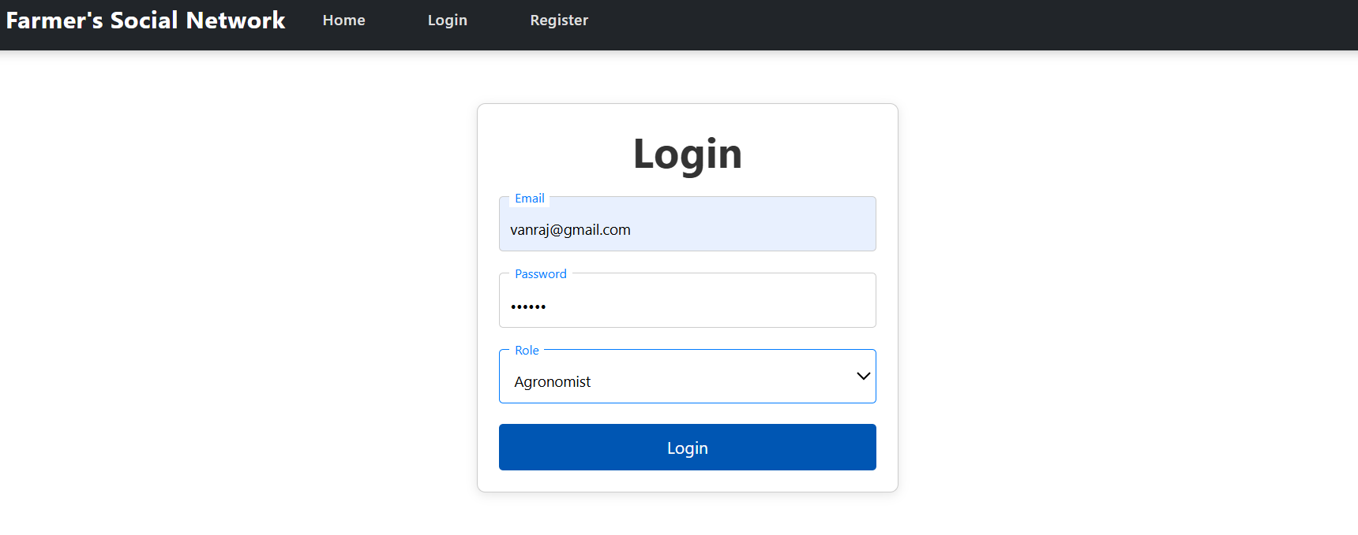

**Figure 7.24** Login For Agronomist

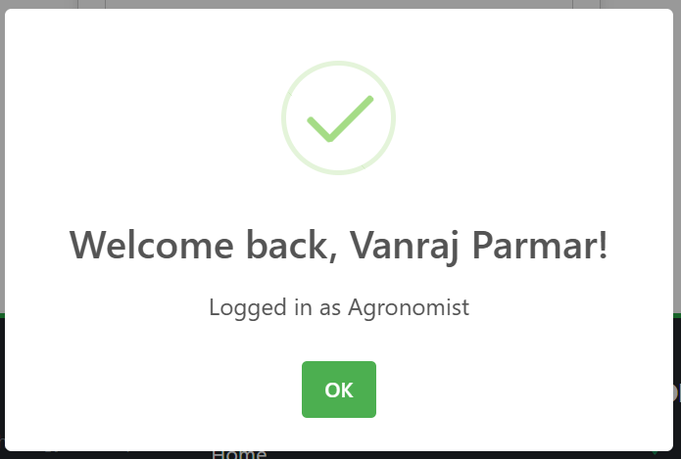

**Figure 7.25** Message For Successful Login

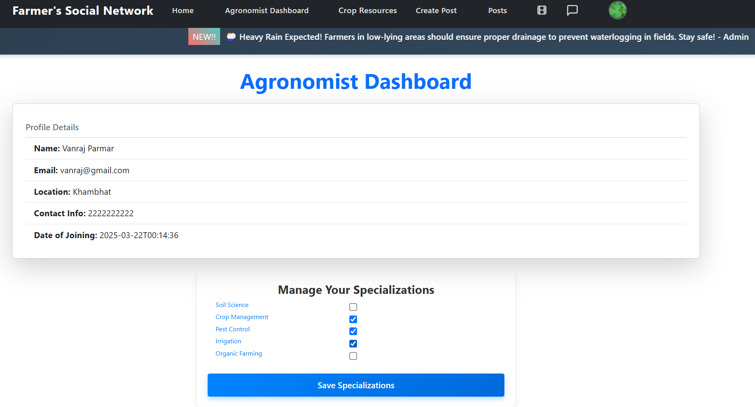

**Figure 7.26** Agronomist Dashboard

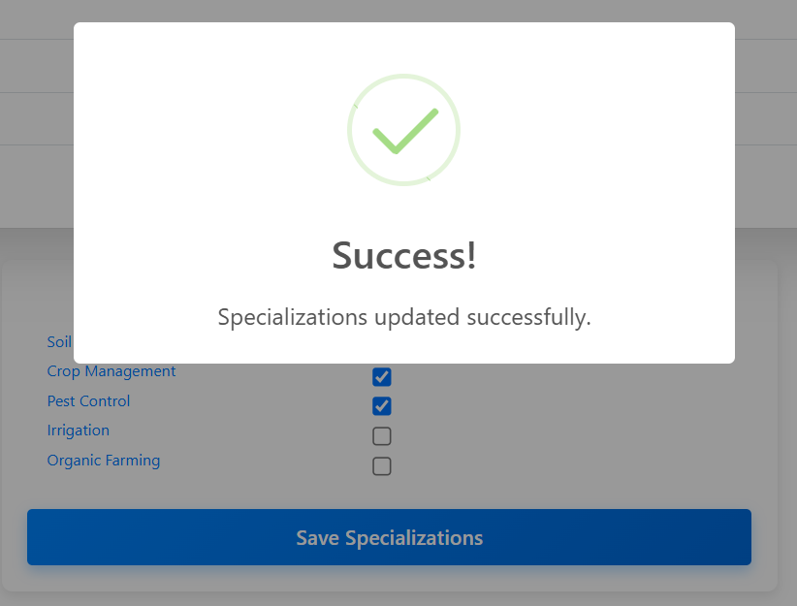

**Figure 7.27** Specification Updation

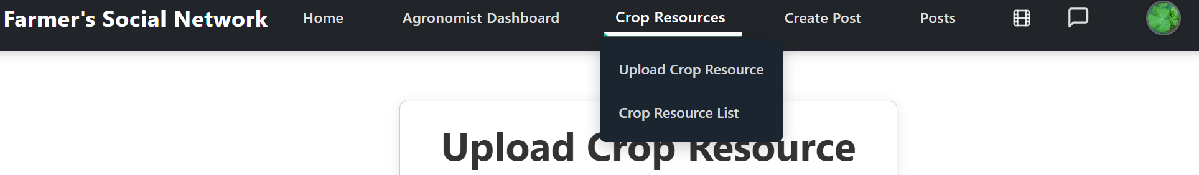

**Figure 7.28** Crop Resource Section Selection

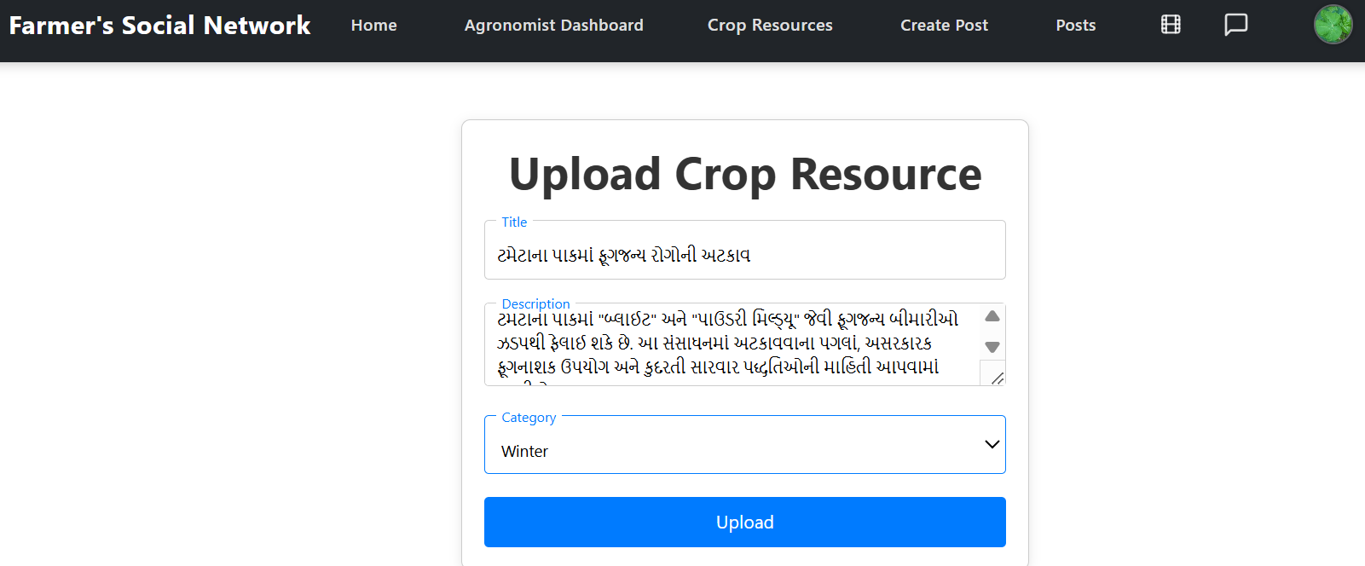

**Figure 7.29** Upload Resources



**Figure 7.30** Message For Successful Resource Uploadation

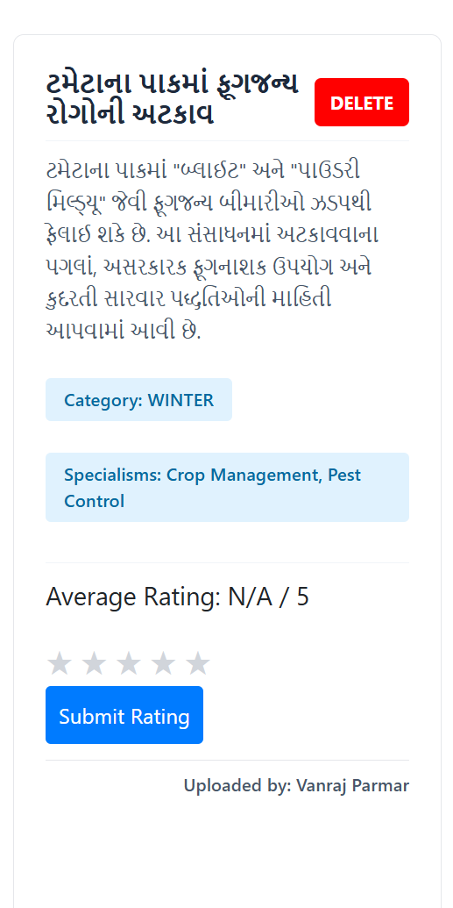

**Figure 7.31** Crop Resource

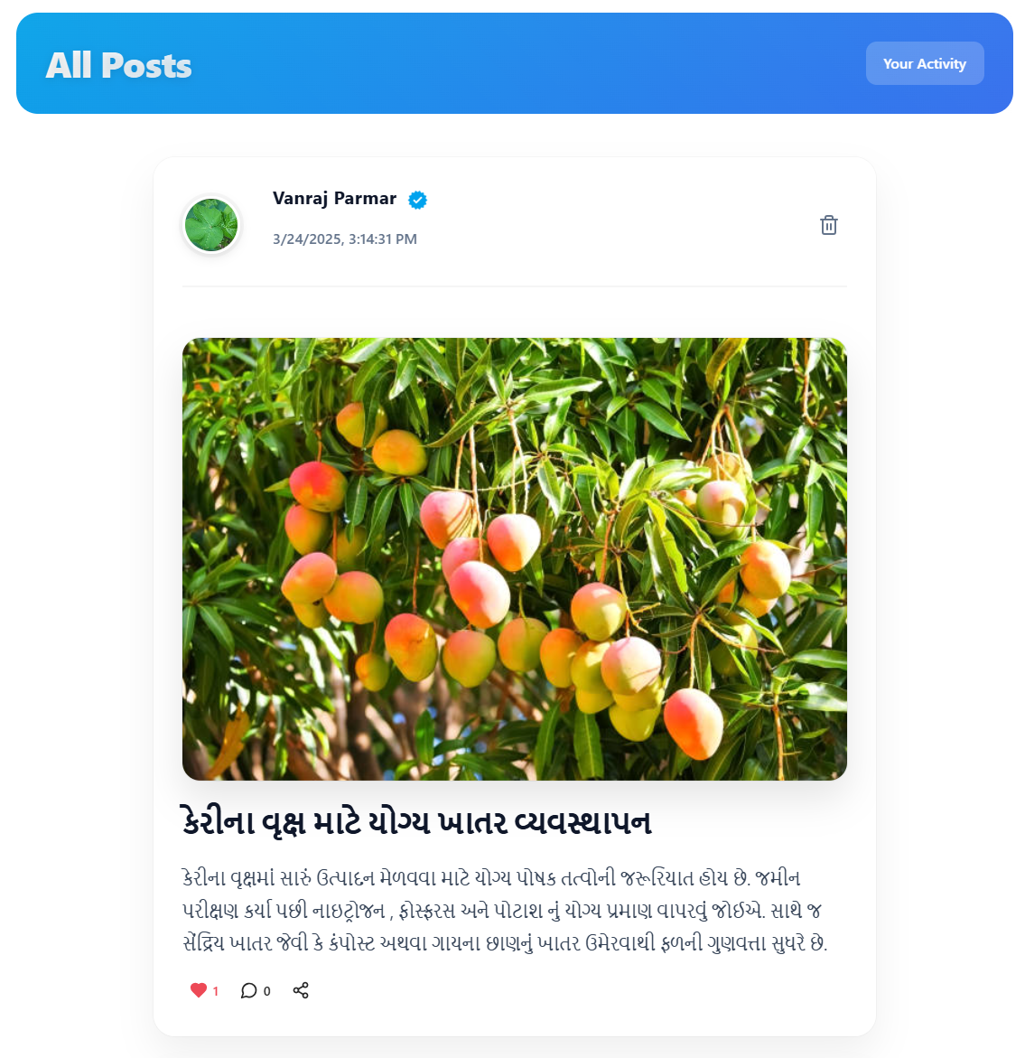

**Figure 7.32** Post For Agronomist

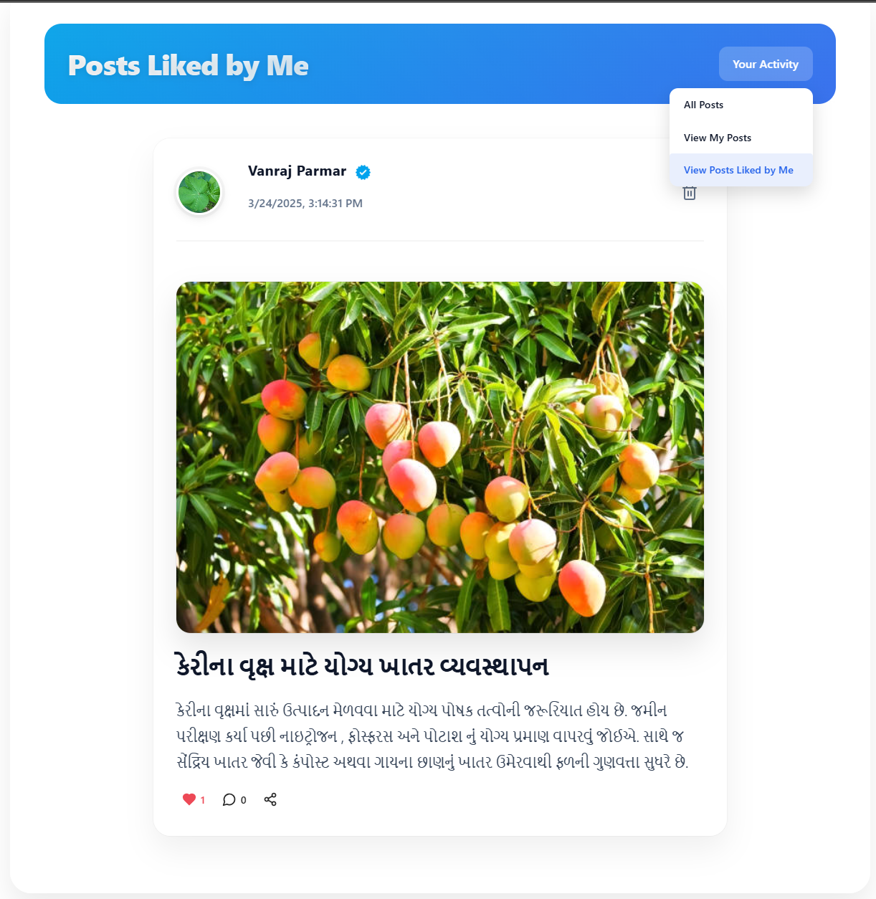

**Figure 7.33** User Activity At Post Section

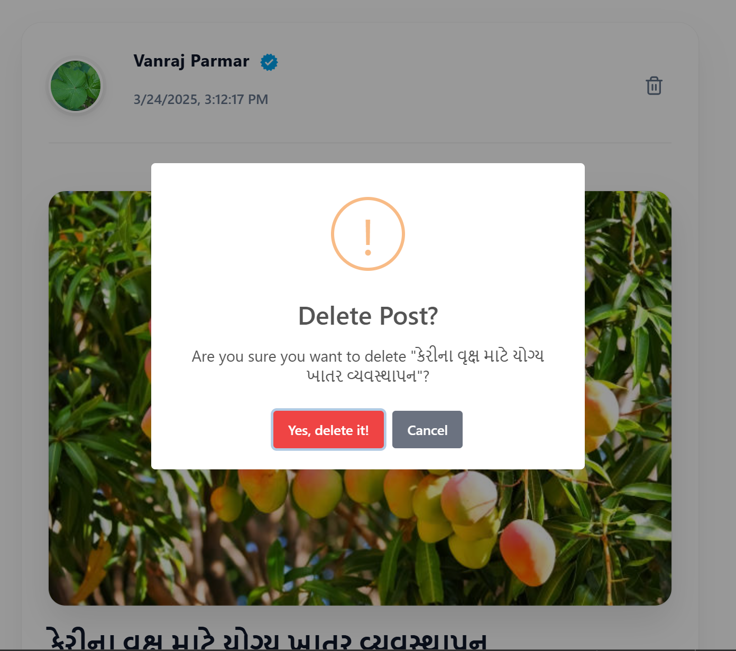

**Figure 7.34** Post Deletion

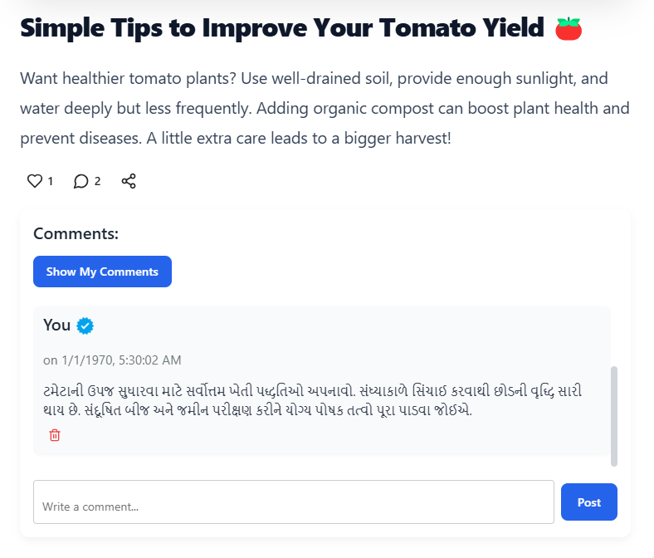

**Figure 7.35** Comment Section

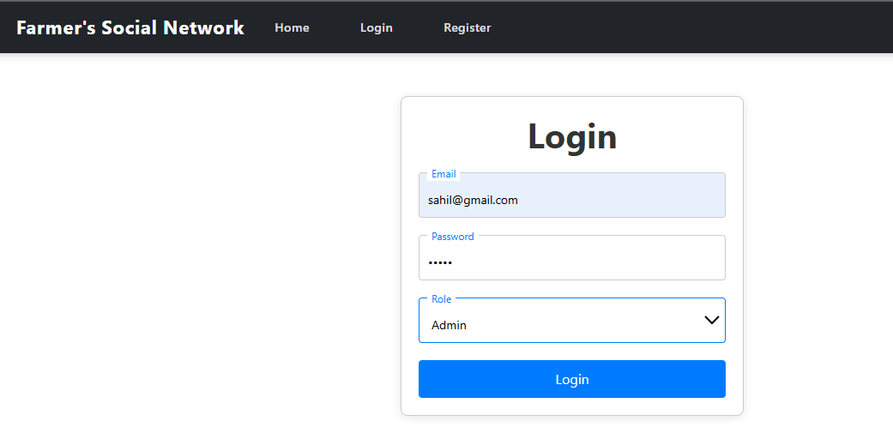

**Figure 7.36** Login For Admin

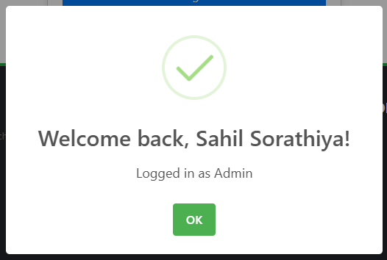

**Figure 7.37** Message For Successful Login

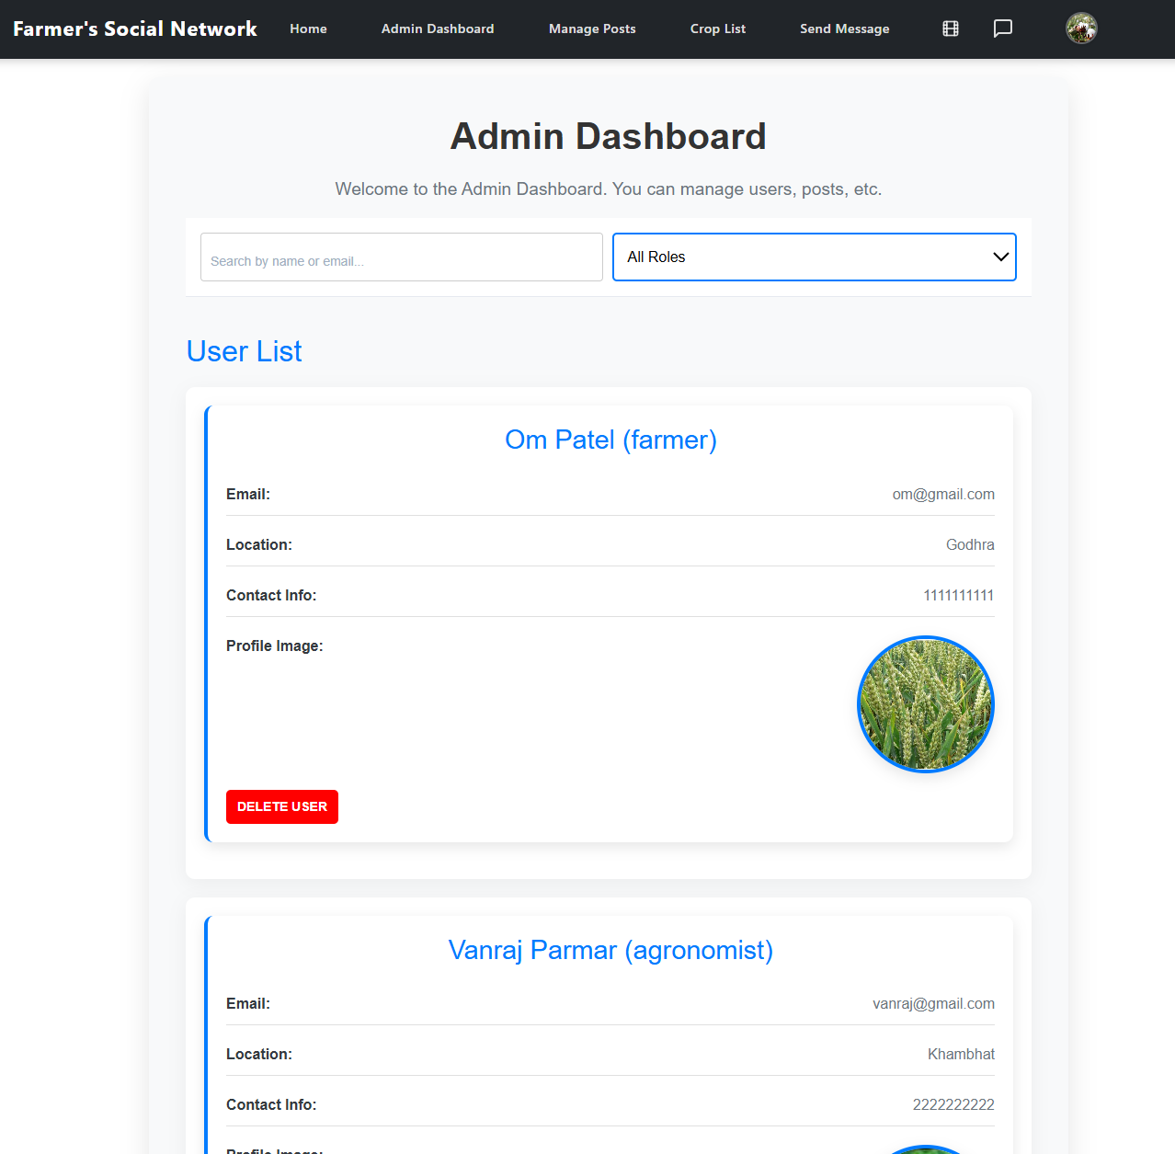

**Figure 7.38** Admin Dashboard

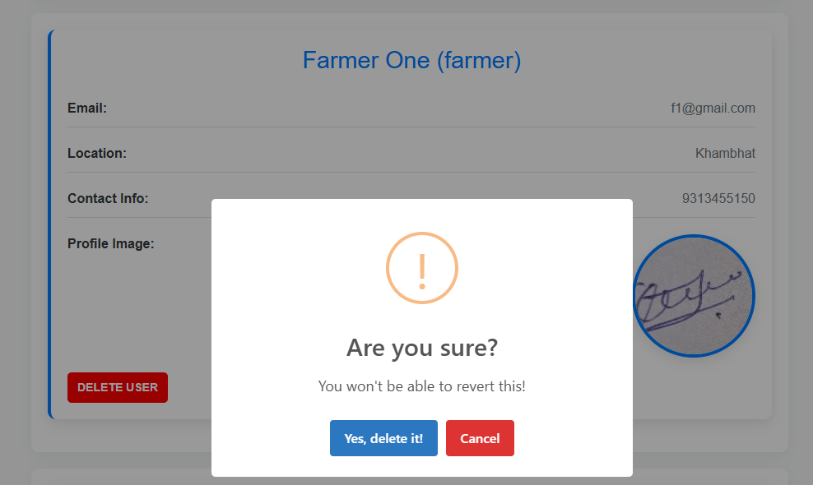

**Figure 7.39** Deletion of User

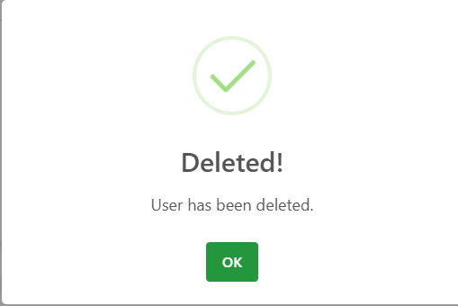

**Figure 7.40** Message For Successful Deletion

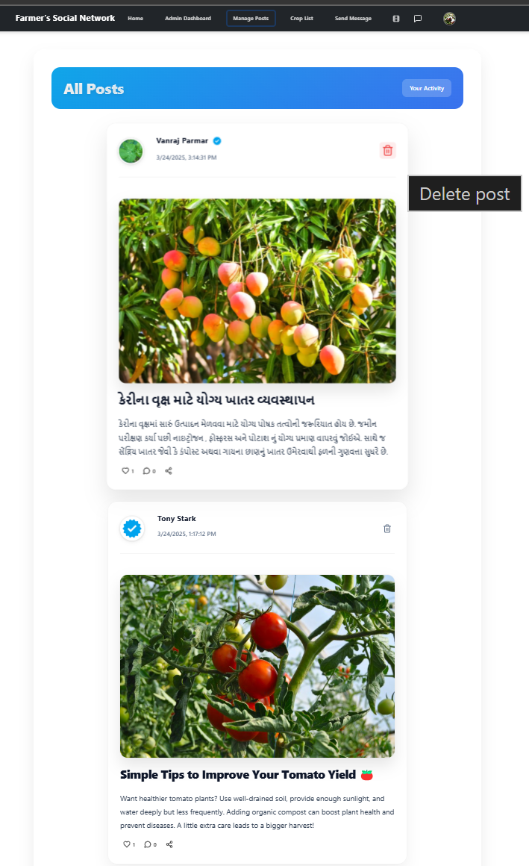

**Figure 7.41** Post Section For Admin

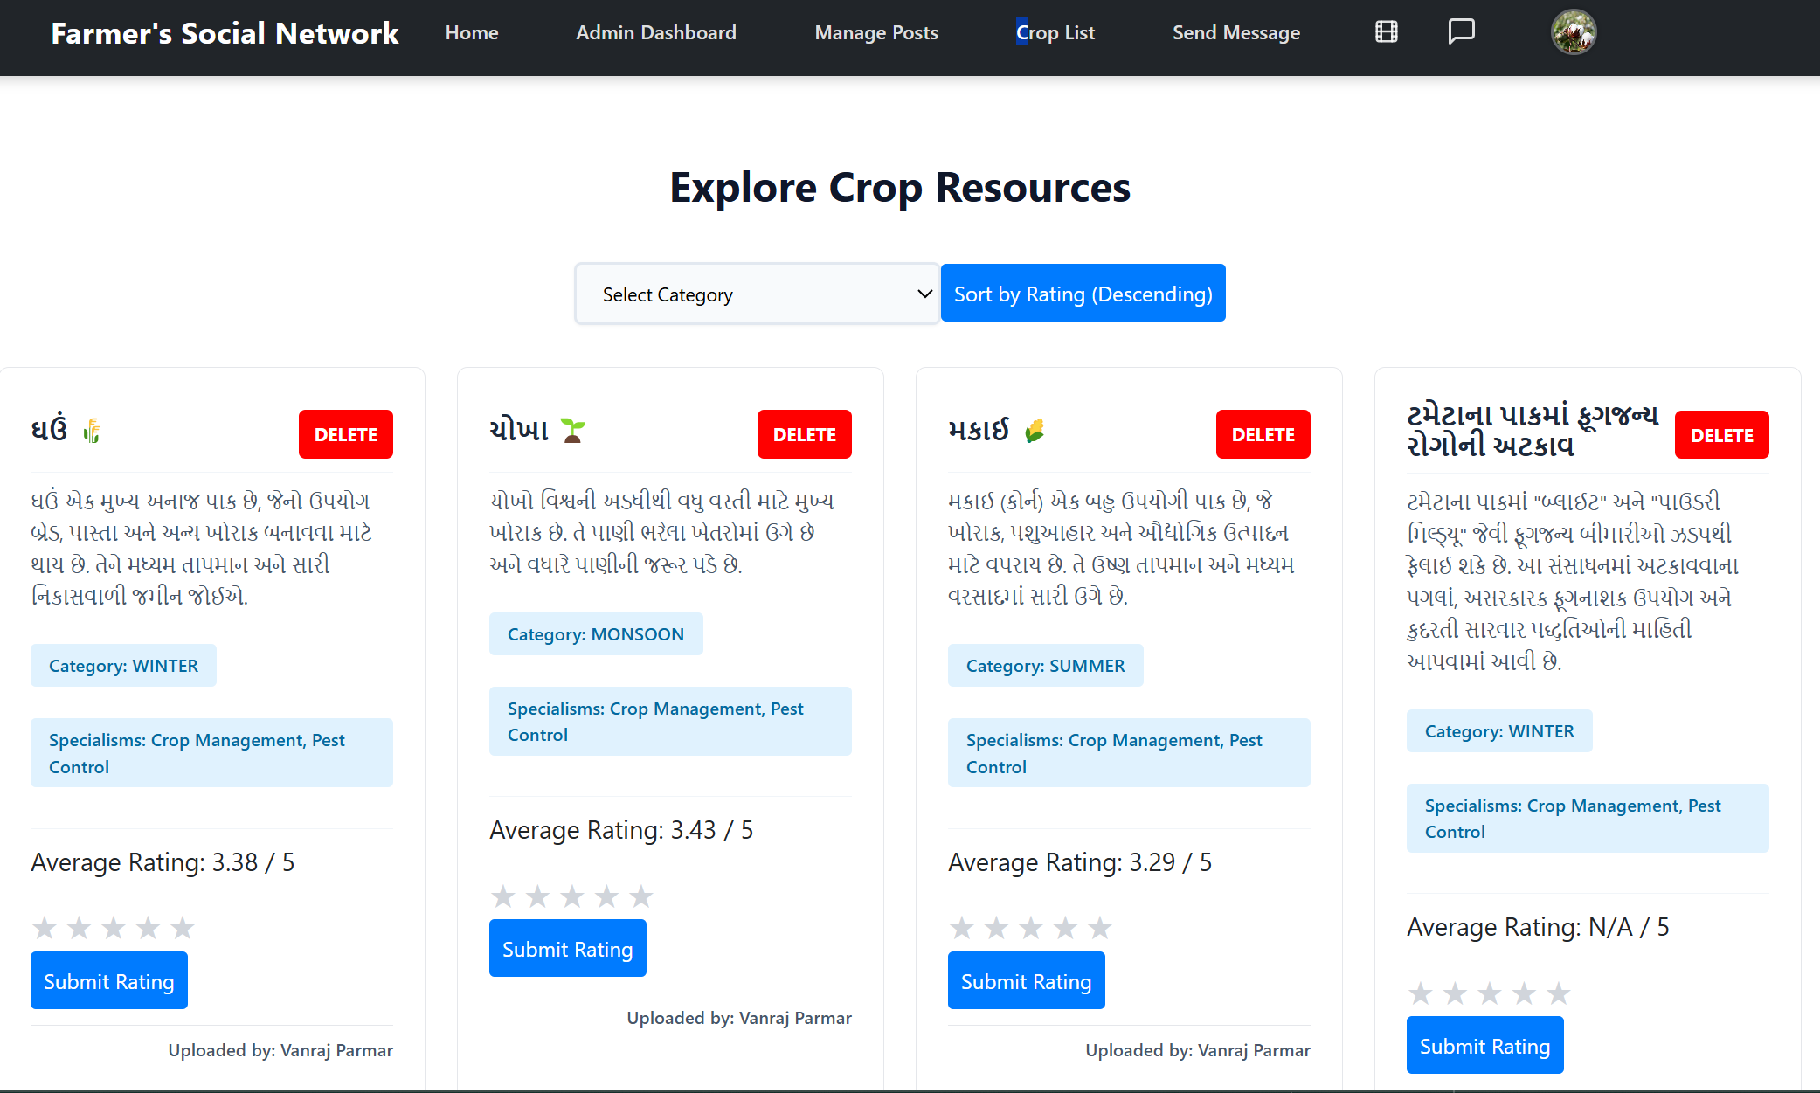

**Figure 7.42** Resource Section For Admin

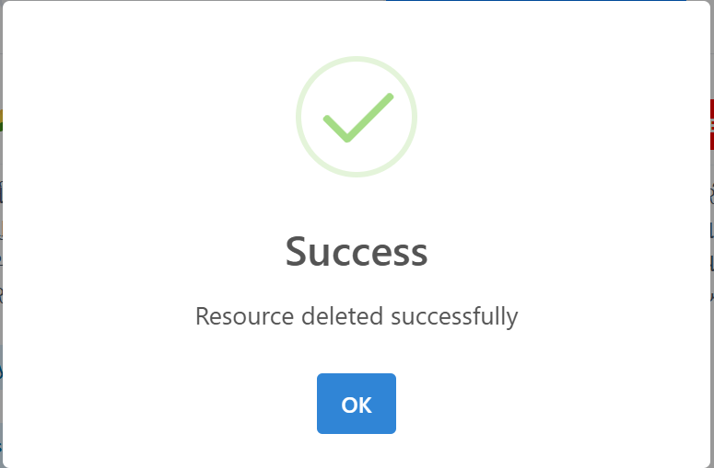

**Figure 7.43** Message For Successful Deletion Of Resource

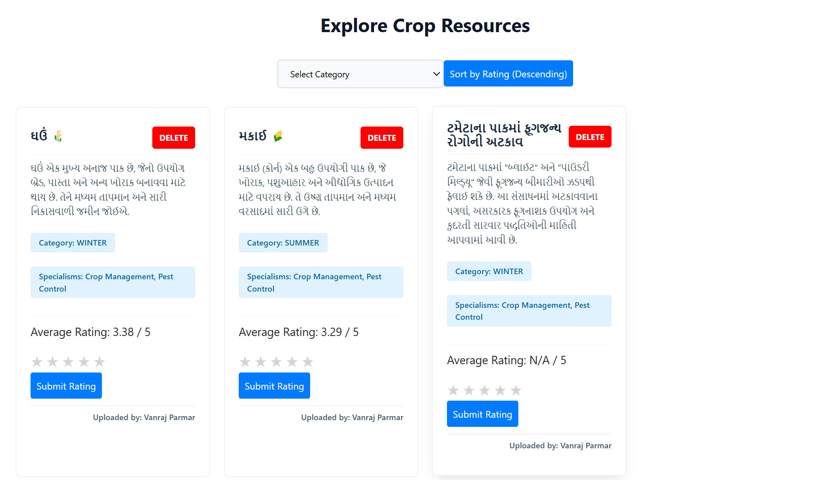

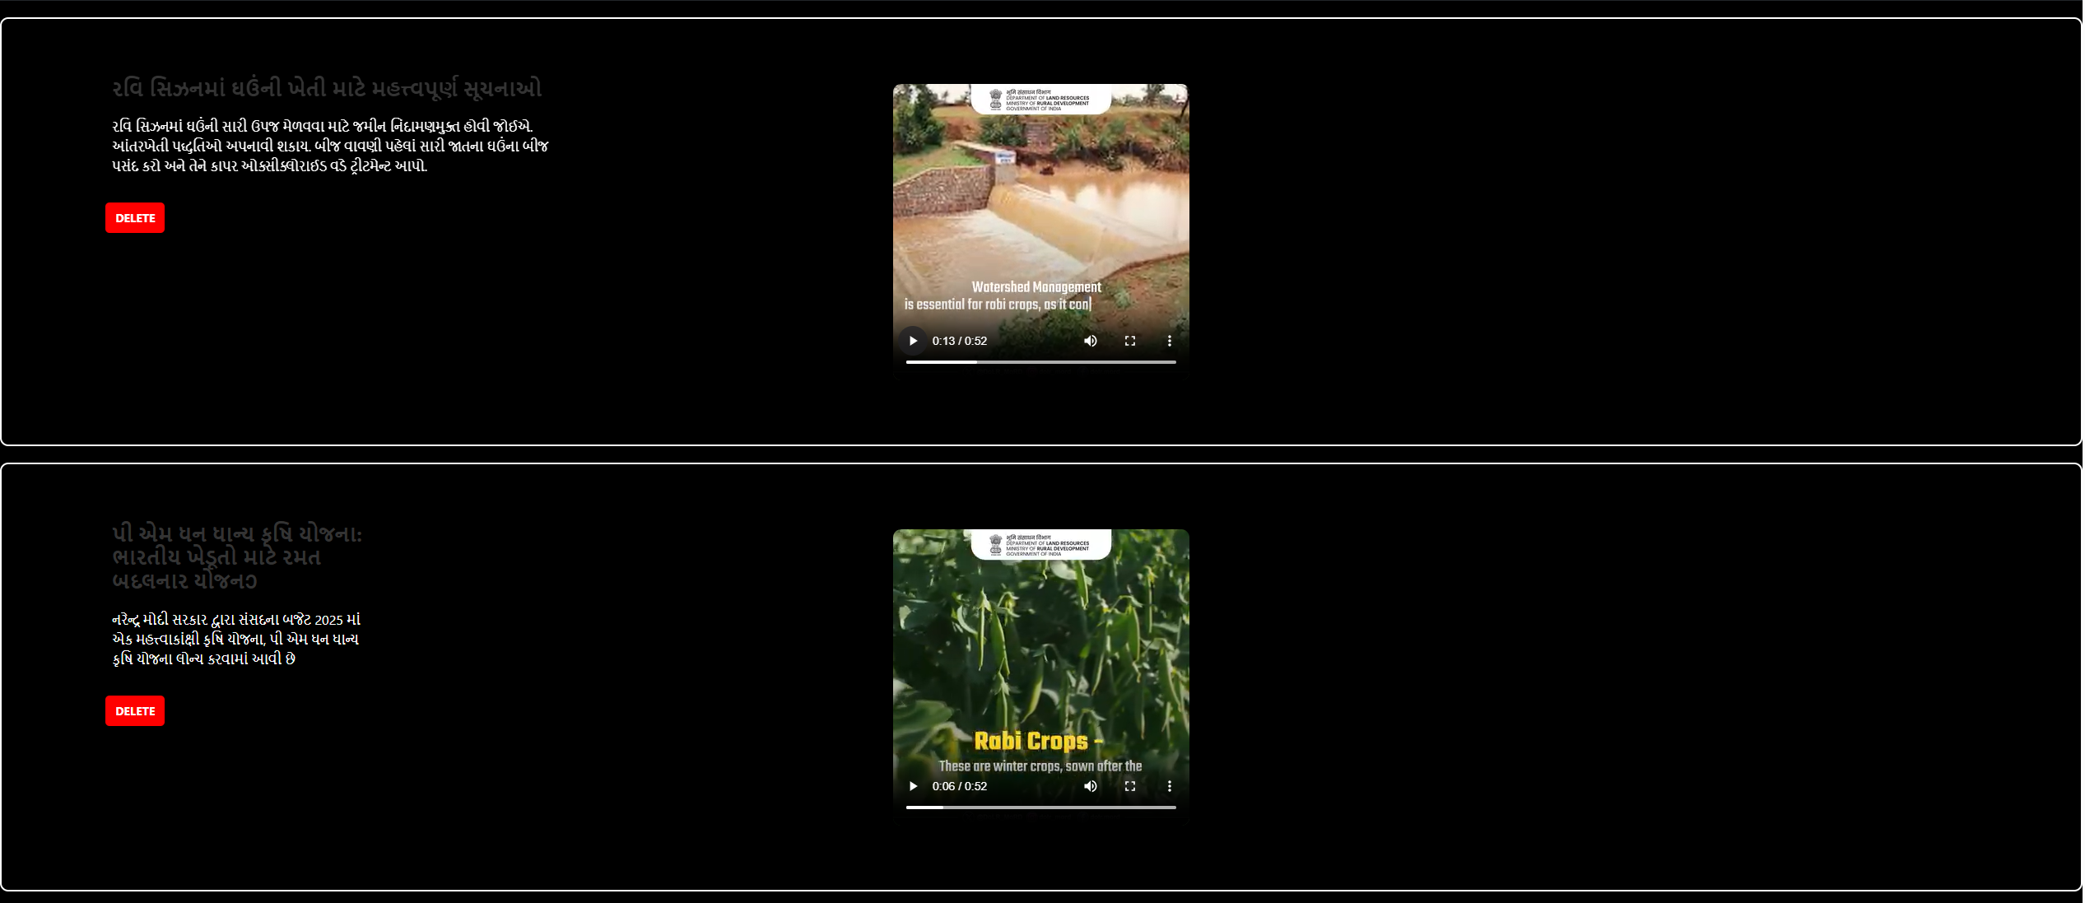

**Figure 7.44** Short Feed Section For Admin

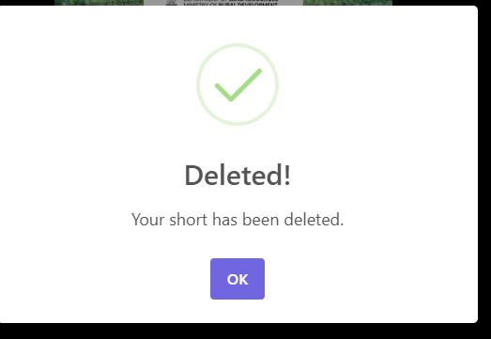

**Figure 7.45** Message For Successful Deletion of Short

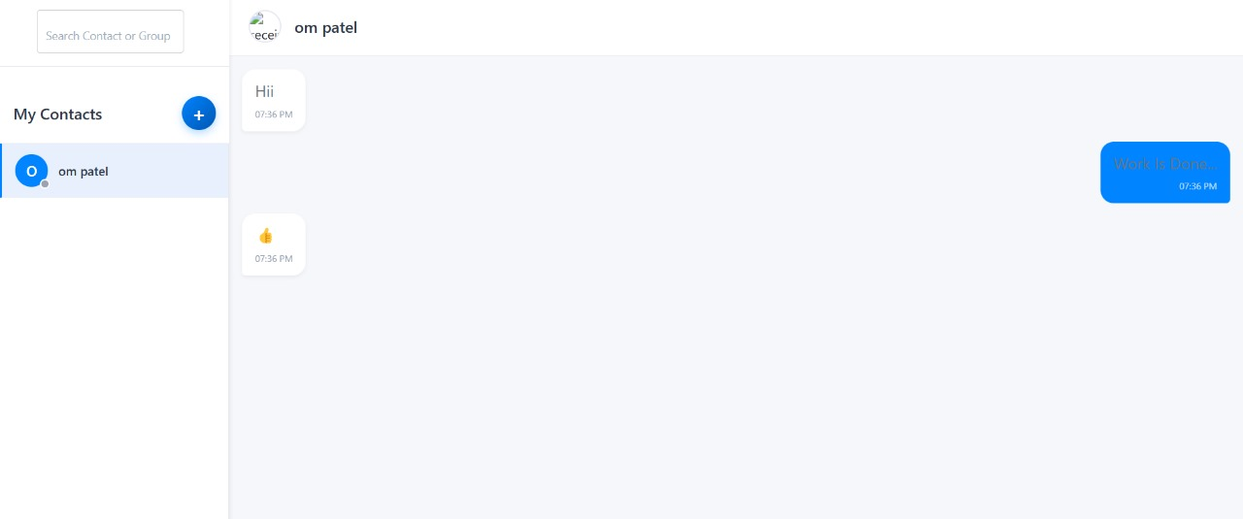

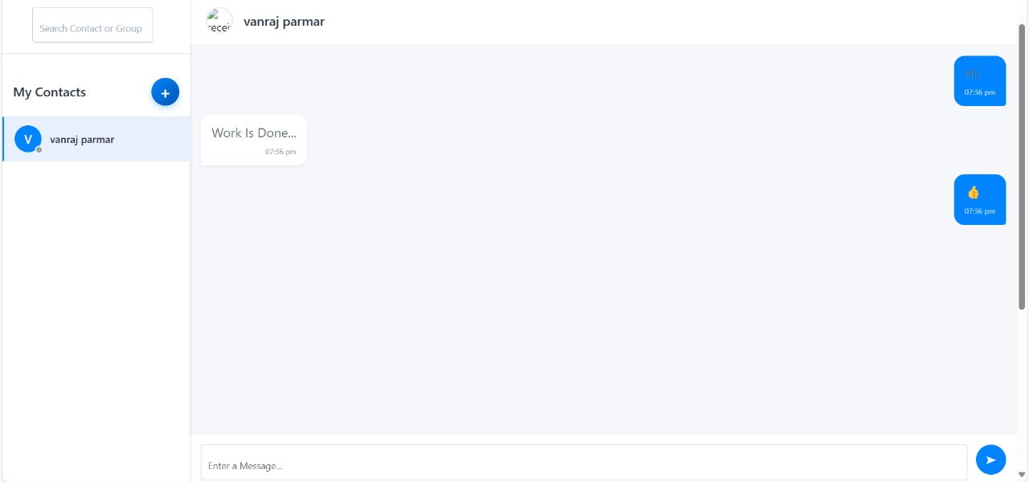

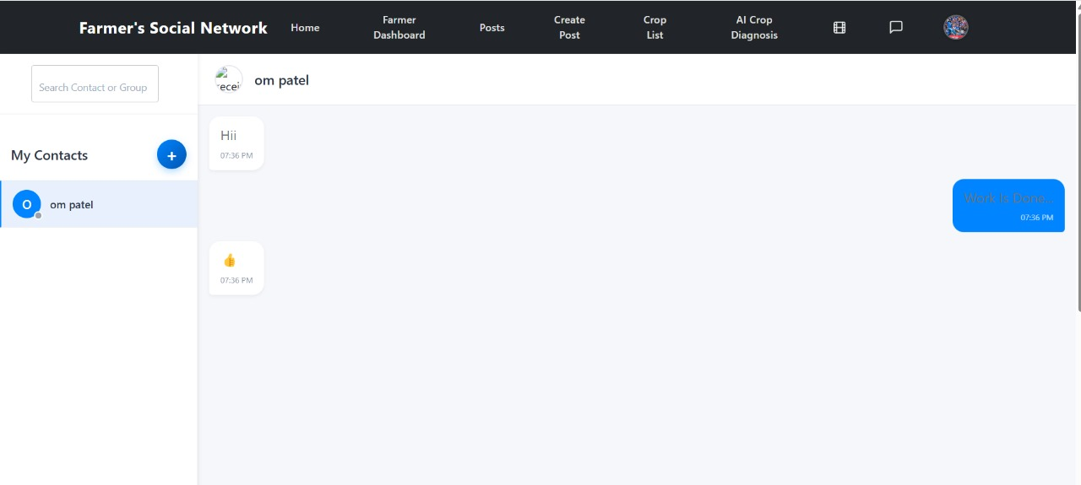

**Figure 7.46** Real-time chat application

### **Chapter 8**

### Conclusion

**8.1 Conclusion**

The Farmer Social Network is a cutting-edge platform designed to empower farmers by integrating modern technology into their cultivation processes. It provides a collaborative environment where farmers can share knowledge, access AI-driven insights, and utilize real-time chat for seamless communication.By incorporating a chat microservice with MongoDB Atlas, the platform enhances community engagement, allowing farmers to discuss best practices, troubleshoot issues, and exchange cultivation techniques efficiently. The Spring Boot backend ensures secure API communication, while the React frontend delivers an intuitive user experience.Additionally, Authentication facilitates seamless integration between services, ensuring data security and smooth interaction between the main platform and chat microservice. With these features, the Farmer Social Network serves as a comprehensive digital ecosystem that modernizes agricultural collaboration, ultimately benefiting farmers by improving productivity and decision-making.

**8.2 Futiure Extensions**

* Expand language support for better accessibility.
* AI prediction is not 100% accurate but around 94.15%.
* Model predicts from only 10 different classes.
* Dependency on external APIs for crop recommendations.
* Enhance AI model training for more accurate disease detection and for large number of classes.
* Start with different services to provide additional agricultural assistance, such as weather forecasting, market price predictions, and automated fertilizer recommendations.

### Bibliography

* Node.js and Express.js Official Documentation:

Node.js: <https://nodejs.org/en/docs/>

Express.js: <https://expressjs.com/en/starter/installing.html>

* MongoDB Documentation: <https://www.mongodb.com/docs/manual/>
* Getting Started Guide with STS – <https://spring.io/guides/gs/sts>
* Machine Learning and Image Processing

• Goodfellow, I., Bengio, Y., & Courville, A. (2016). *Deep Learning*. MIT Press.

• Gonzalez, R. C., & Woods, R. E. (2018). *Digital Image Processing* (4th ed.). Pearson.

• OpenCV Team. (n.d.). *OpenCV Documentation*. Retrieved from https://docs.opencv.org/

• TensorFlow Team. (n.d.). *TensorFlow for Image Processing*. Retrieved from

<https://www.tensorflow.org/tutorials/images>

* Socket.io Official Documentation**:** <https://socket.io/docs/>
* Docker Overview (Getting Started) – <https://docs.docker.com/get-started>
* Building an Application with Spring Boot -<https://spring.io/guides/gs/spring-boot>
* Creating MySQL Database with XAMPP - <https://www.tpointtech.com/creating-mysql-database-with-xampp>
* Crop Disease Images - <https://www.kaggle.com/datasets/jawadali1045/20k-multi-class-crop-disease-images>